2009 Field Notes

Autumn Migration, 2008

Oregon/Washington Region

Douglas Schonewald
Brad Waggoner
Bill Tweit

It's hard to imagine how future autumn seasons might surpass this one in terms of mega-rare discoveries. Like 1974 in California, 2008 may serve as this Region's enduring fall benchmark. The seasons six Regional firsts nearly matches the output—seven new birds for the Region—of the past five autumn seasons combined. These included two species from the Southern Hemisphere, and two more unlikely to appear on anyone's short list of "what's next?" An invasion of sorts from the desert Southwest—The Cactus Express--delivered to our Region several species and subspecies previously unknown, or nearly so, in the Pacific Northwest. These events have reshaped our notion of what is possible. The Region's roster of pelagic species continues to grow, with two additions this fall. However, concerns persist about declining numbers of the more expected marine birds. For the second consecutive fall, inshore flights of some tubenoses were, for reasons unknown, far superior to offshore counts. Exceptional coverage of eastside vagrant traps included one former Regional Editor taking up residence at Malheur 15 September-9 October. In addition to producing some major rarities, these efforts boosted the detections of expected vagrants. Impressive tallies of Chestnut-sided, Magnolia, Black-throated Blue, and Blackpoll Warblers were all at least double the norm. This season's particularly colorful quilt reminds us to acknowledge the ever-increasing pool of talented and dedicated observers who supply us with reports, for without their efforts meaningful commentary would be nearly impossible.

Abbreviations: Ankeny (Ankeny N.W.R., Marion); F.R.R. (Fern Ridge Reservoir W.M.A., Lane); Finley (Finley N.W.R., Benton); Nisqually (Nisqually N.W.R., Thurston); N.S.C.B. (North Spit Coos Bay, Coos); O.S. (Ocean Shores, Grays Harbor); P.N.P. (Point No Point, Kitsap); P.S.B. (Port Susan Bay, Snohomish); P.T. (Puget Trough); Ridgefield (Ridgefield N.W.R. Clark); S.J.C.R. (South Jetty Columbia R., Clatsop); W.V. (Willamette Valley); W.W.R.D. (Walla Walla River Delta, Walla Walla); "eastside" and "westside" refer to areas e. and w. of the Cascade Crest, respectively.

WATERFOWL THROUGH CRANES
A major push of Greater White-fronted Geese during the first week of Oct coincided with the season's first significant low-pressure system, which grounded many flocks and increased detection of low-flying migrants; 1500+ passed over Portland during a 15-minute period 7 Oct (G. Neavoll). Lone imm. Emperor Geese at Hillsboro 14 Oct+ (GGi et al.) and Corvallis 23 Oct (J. Simmons) were in the WV, where not annual. Single Snow Geese near Bay Center, Pacific (CW) and Burlington, Skagit (RT), both 24 Aug, were more than a month early. Blue Geese again joined the s. Skagit/n. Snohomish Snow Goose flock, with 6 noted 11 Oct-9 Nov (SM). A banded ad. Snow Goose originating from Banks I., Canada graced Fir I., Skagit 8 Nov (M. Axelson); some Snows from both Banks I. and Siberia's Wrangel I. winter in California's Central Valley. (As nearly all the Wrangel birds pass through w. Washington and w. British Columbia, it is thought that Blue Geese first arrived on Wrangel after pairing with Snow Geese in the Central Valley, and then migrating to Wrangel to breed. One is left to wonder if this Banks I. Snow Goose is paired with a Wrangel native and now part of the "Wrangel population" rather than a direct vagrant.) Eight stray Ross's Geese were detected 31 Oct-22 Nov, including 4 in e. Washington and 2 in Crook 2 Nov (CG); westside singles visited Finley 9 Nov (L Millbank) and Sauvie I. 22 Nov (B. Sundstrom). Single minima and taverneri Cackling Geese at O.S. 7 Aug (CW) had probably summered locally; migrants typically arrive in late Sep. Four minima were near Potholes Res. 26 Oct (SM, BW); this tax-on is now found Windemuth) was thus most surprising. Single Brant were at Kent, King 18 Oct (CW), at Ridgefield 7 Nov (BF), and at Marymoor, King 26 Nov (B. Bell). For the 2nd consecutive year, an exotic Red-breasted Goose turned up in the n. WV; one was at Fernhill Wetlands, Washington 26 Oct (HN).
An ailing Tundra Swan frequented F.R.R. 27 Aug+ before succumbing 17 Sep (LM, DF). Three westside Tundras, 2 in Oregon and one in Washington 20 Sep-8 Oct (†A), were about a month early. Single Bewick's Swans at Chickahominy Res., Harney 26 Oct (ph. SDn) and Ridgefield 1 Nov (ph. C. Ledford) are the Region's first during the fall season; the 20+ antecedent records have occurred 9 Dec+. A Eurasian Wigeon at P.S.B. 14 Sep (SM, DI) was the earliest report by three weeks. A goodly 5 Eurasians were in e. Washington, matching last fall's tally, which was the best since 2003. An American Black Duck was noted again at Juanita, King 3 Aug-18 Oct (RM). We've learned that a waterfowl breeder in Woodinville, King has had up to 20 free-flying American Black Ducks in his collection during the past five years, half of which have disappeared. It is quite possible that the Juanita bird originated from this collection. A Blue-winged Teal x Northern Shoveler at Ridgefield 29 Nov + (ph. SC) is the first report of this rare hybrid for Washington. The season's only Eurasian Teal was at Fernhill Wetlands, Washington 26 Oct (LN, C. Warren). A tally of 15,000 Green-winged Teals at Lummi Bay 29 Nov matched the Washington record (SM, RM).
This season's Tufted Duck stopped at Philomath 8 Nov (WDR). Three fuzzy juv. Buffleheads at Migraine L., Grant 4 Aug were well s. of known e. Washington breeding sites. (One wonders if the local Wood Duck nest box program contributed to this rare nesting record or if, like the Barrow's Goldeneyes at L. Lenore, Buffleheads are cliff-nesting in rimrock cam ties.) The 50,000 Surf Scoters that passed Boiler

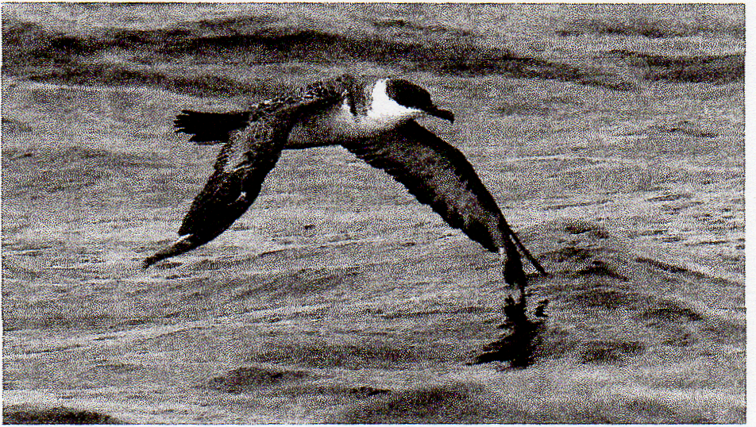
Oregon finally joined the list of Pacific states with Greater Shearwater records when this bird appeared 27 kilometers off Newport, Lincoln County on 9 August 2008. The Oregon & Washington region's two antecedent records are both from Washington. Photograph by Dan Barton

143 Volume 63 (2009) Number 1, Autumn Migration
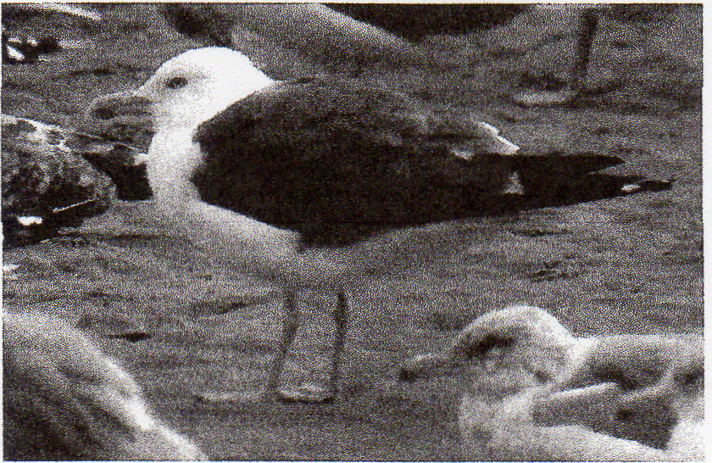
Though detected annually in Washington over the past five years, Lesser Black-backed Gull had been found just once in Oregon—until this adult was photographed at Newport 10 August 2008, a state second. Photograph by Glen Lindeman.

Bay 4-5 Nov (PP) marked the peak southbound flight. Thirty-one eastside Surfs 12 Oct-30 Nov was 10 shy of recent averages. Eastern Washington's 12 White-winged Scoters included 2 at Wenas L., Yakima 15 Aug (J. Kozma) that were about a month early. Three Harlequin Ducks at Sprague L., Adams 13 Oct (RH) and another at Blue L., Grant 1 Nov (T. O'Brien) were in the e. Washington lowlands, where not annual in fall. A measly 3 Long-tailed Ducks were detected on the eastside, where the recent norm is 7+; one on Upper Klamath L. 29 Nov (D. Haupt) was away from the favored Mid-Columbia Basin. A Barrow's Goldeneye x Common Goldeneye was at Blaine, 'Whatcom 29 Nov (ph. SM, RM); this hybrid is now detected annually in the Region. On 3 Nov, a male Barrow's Goldeneye returned to Astoria for its 8th consecutive winter. Another Barrow's graced Tillamook 16 Nov (A&CH, ES); this species is barely annual along the Oregon coast.
Loon flights peaked at Boiler Bay during early Nov (PP); 6,000 Red-throated Loons passed there 4 Nov and 23,000 Pacifies were tallied in 90 minutes on 13 Nov. Two Yellow-billed Loons at Pt. Wilson, Jefferson 2.8 Oct+ (B. Whitney) and another at P.N.P. 25 Nov+ (VN) comprised a typical fall showing. Western Washington's 11 Clark's Grebes was above average. Four at Bainbridge I., Kitsap 15 Nov (BW, GG) were noteworthy, as few P.T. records have involved multiple birds.
Fourteen offshore trips included 7 out of Westport, one out of LaPush, Clallam, five out of Newport, and one out of Brookings. Half of these trips were in Aug. As noted during summer, low counts of many seabirds continued. However, there were rarities aplenty, with two new species for the Region and four state firsts. Regionally, Black-footed Albatrosses seem to be in slow decline; off shore trips averaged fewer than 40, with a high count of 94. This drop-off may be connected to reductions in offshore trawling and associated discards. All 5 Laysan Albatrosses were in Oregon waters 12 Aug-29 Sep. Photographs of the Region's first Wandering Albatross, off Newport Sep 13 (ph. GGi et al.), depict a female of the Antipodean population. Some authors treat the taxa of Wandering Albatross as separate species, with this taxon referred to as Antipodean Albatross (Diomedea antipodensis). The American Ornithologists' Union's Check-list Committee has not voted on this split. The only prior North American record of this complex involved one onshore at Sea Ranch, Sonoma, CA 11-12 Jul 1967. A well-described Hawaiian Petrel 257 km w. of Newport 7 Aug (†M. Force) and another photographed off Westport 27 Sep (BT et al.) were also new to the Region; photographs of the latter bird seem to eliminate Galapagos Petrel (see Force, M. P., S. W. Webb, and S. N. G. Howell. 2007. Identification at sea of Hawaiian and Galapagos Petrels. Western Birds 38: 242-248). Satellite tracking has shown that Hawaiian Petrels occasionally disperse northward to 51° N in the cen. Pacific Aug—Sep, well n. of these reports. The year-long trend of below-average Northern Fulmar numbers continued, with only three counts of 100+. A tally of 3,500 Pink-footed Shearwaters inshore at Boiler Bay 4 Oct (PP) is utterly unprecedented and even more surprising when one considers that Oregon's Aug—Sep pelagics averaged fewer than 100/trip. This marks the 2nd consecutive Oct with major inshore flights of Pink-footeds; Oct 2007 saw several counts of 500+. A lowly 4 Flesh-footed Shearwaters were reported all season. Oregon's first and the Region's 3rd Greater Shearwater was 27 km nw. of Newport 9 Aug (GGi, ph. D. Barton); antecedent records came from 67 km off Grays Harbor 24 Aug 2002 and off Westport 10 Sep 2006. Mirroring Pink-footed Shearwater, Buller's Shearwaters were scarce offshore Aug—Sep (fewer than 20/trip), but 50 counted from shore at Coos Bay on Oct 7 (JD) was exceptional and perhaps indicative of a later-than-normal passage. Sooty Shearwater numbers were low all season, with no reports topping 5,000 birds. As is typical, 3 of the season's 4 Manx Shearwaters were observed from coastal headlands 5 Aug-7 Oct; a single off Westport 5 Sep furnished the only at-sea sighting (fide BT). A gathering of 6,000 Fork-tailed Storm-Petrels 8 km off Newport 10 Aug (T. Johnson) makes a Regional record, nearly tripling Washington's all-time high count (2,400); the Region's breeding population numbers only about 4,000 birds. Three Fork-taileds were inshore at Boiler Bay 4 Oct (PP). A Leach's Storm-Petrel off P.N.P 27 Sep (VN) was very rare in the PT., where most prior records have occurred mid-Oct—mid-Nov.
The Region's 6th Brown Booby⁻ washed ashore dead at Coos Bay 27 Oct (G. Friedrichsen); a live bird 24 km sw. of Depoe Bay, Lincoln 3 Oct 1998 represents the only previous Oregon record. Prior to 1997, a Blue-footed Booby at Everett 23 Sep 1935 was the Region's lone sulid record. Since then, nine boobies of three species have reached our shores. American White Pelicans are now commonplace in the VW, with 125+ reported from eight locales this season; these included daily maxima of 54 at F.R.R. 27 Aug (RR) and 44 at Sauvie I. 21-24 Sep (AF, JG). One at Bandon 1 Aug (TR) and 2 at Plat Island Res., Douglas 30 Oct-2 Nov (R. Maertz) were less expected. Twenty-six Brown Pelicans in the P.T. 14 Aug-17 Nov was about thrice the norm and included an amazing 20 over West Pt., King 18 Oct (B. Dudley). Eastern Washington's 5th Brown Pelican surely puzzled hawkwatchers as it cruised over Chelan Ridge, Chelan 17 Oct (fide V. Glick). Coastal pelican numbers remained extremely high through the season, evidenced by 3686 passing Lincoln City, Lincoln 16 Nov (PP). An unidentified frigatebird was 100 km w. of Tillamook 8 Aug (S. & D. Parsons).
Once again, large numbers of post-breeding Great Blue Herons (258 on 11 Oct) and Great Egrets (482 on 5 Oct) gathered at Portland's Smith/Bybee Lakes Sep—Oct (AF, S. Nord). An imm. Snowy Egret frequented F.R.R. 21 Aug-5 Oct (JS, m.ob.); this species is now nearly annual in the WV, where formerly extremely rare. Single imm. Little Blue Herons at Smith/Bybee Lakes. 1-3 Sep (D. & S. McCarty, JN, ph. SF) and Neskowin, Tillamook (†J. Hurt) were Oregon's 5th and 6th and the first for fall. After a decade of poor showings, Cattle Egrets invaded w. Washington, with 23 reported 22 Aug-30 Nov, including a flock of 15 off Rosario Head, Skagit 1 Nov (J. Parrott). A surprising Green Heron visited Burns Junction, Malheur 8 Nov (K. Cottrell); they are rare at any season in se. Oregon and all but unknown there Oct—Mar. A White-faced Ibis tarried at Wood R. Wetlands, Klamath until 6 Nov (RR); ibis are rarely found in the Region after early Oct.
Five of Oregon's 7 lowland Northern Goshawks appeared 6 Oct-16 Nov, while early birds enlivened S.J.C.R. 21 Aug (JGi, JM) and Green Peter Res., Linn 31 Aug (JGe). Red-shouldered Hawks continue to increase on Oregon’s eastside, where mega-rare prior to 1990. There were 20 reported from 16 locations

144 NORTH AMERICAN BIRDS, Autumn 2008

in Deschutes, Harney, Klamath, and Lake 5 Aug-14 Nov. Body parts of a dead imm. at Fields, Harney 9 Aug (DI, DPe), and the capture of an imm. at the Green Ridge, Jefferson hawkwatch 28 Aug, invite questions about where these birds hatched. About par for recent years, 5 Red-shouldereds were noted in w. Washington 23 Aug-29 Nov; the northernmost was a returnee at Kent, King 8 Nov+ (K. Andrich). Washington's 3 Broad-winged Hawks included singles on the eastside at Beverly, Grant 9 Sep (SM, DI, BW) and Washtucna, Adams 12 Sep (TL, RH), and a rare westside bird was over Auburn, King 8 Oct (CW); Washington's 15 "accepted" records is deceiving, as many sightings from hawkwatches in Washington's Cascades, where this species is likely annual, remain undocumented. All but one of Oregon's 6 Broad-wingeds were recorded at the Bonney Butte, Hood River hawkwatch (RGe), where annual in fall; the other graced Malheur 10 Oct (R. Phillips, W. Wolfe). Not annual in w. Washington, an impressive 3 Swainson's Hawks included singles at Snoqualmie, King 10 Sep (J. Tubbs), at Marymoor, King 13 Sep (HF), and near Vancouver L., Clark 26 Nov+ (imm.; ph. L. Topinka); this continues the recent string of fall and wintering Swainson's on the westside. A Gyrfalcon at Lost L., Linn 5 Oct (TC) was the season's only report; the Region averages about 4 per fall. Three westside Prairie Falcons 3-29 Nov (2 in Oregon, one in Washington) was also sub-par. Late for e. Washington, 3 Sandhill Cranes visited Duley L. and Cam L., Okanogan 27 Nov. (CW).

SHOREBIRDS THROUGH WOODPECKERS
An ad. Black-bellied Plover visited Lind Coulee, Grant 2 Aug (SM, CCx); ads. are not annual on the eastside. All but 2 of 20 west-side American Golden-Plovers 24 Aug-25 Oct were in Washington, with a maximum of 5 at O.S. 16 Sep (CW). The eastside's lone American was at Philleo L., Spokane 30 Sep (MW). Fifty-one Pacific Golden-Plovers 1 Aug-5 Nov fell shy of recent averages. Fifteen at favored O.S. 16 Sep (CW) was the maximum, while Oregon's high count was a paltry 4 at N.S.C.B. 25 Aug (TR). As usual, a handful of golden-plovers were left unidentified to species. The 106 Black Oystercatchers congregated at Cape Flattery Clallam 24 Oct (D. Wheelan) was unprecedented for the Region. An oystercatcher near Tacoma 17 Nov was a Pierce first and the most southerly record for the P.T. (G. Mc-Cwethy). An active Snowy Plover nest and two broods of days-old chicks were at the s. end of L. Abert, Lake 9 Aug; these late nestings may be timed to coincide with this site's brine fly hatch. Snowies are rarely encountered away from the Region's known nesting and wintering sites; thus a migrant at Chickahominy Res. 13-20 Sep (SDn, RN) was noteworthy. Rare westside American Avocets included 2 at F.R.R. 24 Aug and another that tarried at P.S.B. 17 Sep-30 Oct (M. Reid); there are few westside records after Sep, though w. Washington has two winter records. A Black-necked Stilt at Beaver Cr. marsh, Lincoln 19-22 Sep (M. Noack, ph. D. Comfort) provided the Oregon coast's first fall record—a month after the departure of the WV nesting population. The 190 Greater Yellowlegs at P.S.B. 11 Oct represent Washington's highest inland count ever (SM). The Wood Sandpiper that inhabited F.R.R. 26 Sep-5 Oct (ph. JS) was the Region's first and just the 6th for the Lower 48. Seventy-nine Solitary Sandpipers 1 Aug-22 Sep approximated recent averages. Interestingly, Washington accounted for all but 3 of 56 eastside birds, while Oregon generated 16 of 23 westside reports. Single Willets along
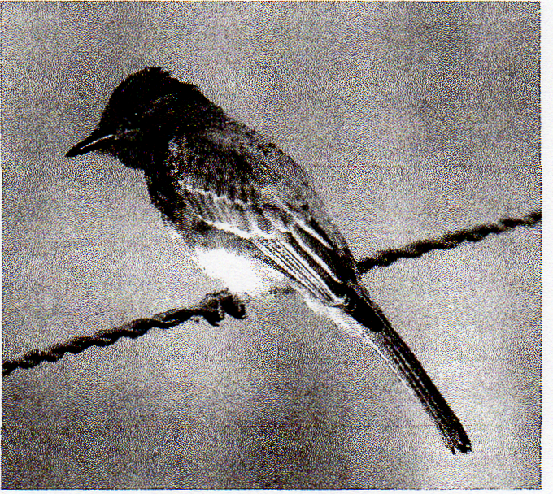
This photograph taken at Summer Lake Wildlife Management Area 17 August 2008 not only documents the first first record of Black Phoebe for Oregon's Lake County but also suggests that this species has nested in the county: the wing coverts' broad buffy margins and the orange gape flanges indicate that this bird had fledged recently. This location is at least 130 kilometers east of the nearest known breeding outpost. Photograph by Scott Carpenter.

Sunset Beach 27 Aug (JC, JGi, OS) and at Seaside 3 Sep (D. Bailey) were in Clatsop, where not annual. Another at Nisqually 15 Nov (P. Hicks) was similarly unexpected in the P.T. Twenty Willets at Tokeland; Pacific 23 Oct (RM) was the high coastal count. A Wandering Tattler, rare for the PT., lingered at Bainbridge I., Kitsap 23 Aug-17 Sep (BW), while one at Newport 29 Nov (M&MLD) was more than a month late.
An Upland Sandpiper circling the NOAA research vessel McArthur II 255 km. w. of Yaquina Head 7 Aug (MF, ph. S. Webb) was most unexpected. Two Whimbrels at Summer L. 28 Aug (D. Stein) and another at Chickahominy Res. 12 Sep (SDn) were on the eastside, where less than annual in fall, Three Long-billed Curlews visited inland valleys on the westside, where rare; singles were at Eugene 5-8 Aug (R. Holland, TM), Finley 17-18 Aug (M. Hunter), and Ridgefield 13 Sep (BF). An ad. Hudsonian Godwit graced Tokeland 2-11 Aug (ph. CW, vt. BW); though annual in the Region, records of ads. are few. A juv. Hudsonian at P.S.B. 8 Sep provided a very rare record for the P.T. (ph. MB). Bar-tailed Godwit went undetected in the Region for just the 3rd fall since 1975. Marbled Godwit now averages about 3 eastside birds per fall; this season, singles were at W.W.R.D. 16 Aug (M&MLD), n. of Potholes Res. 23 Aug (R. Friesz), and at Malheur 28 Sep (S. Shunk). Two Marbleds at Dungeness Bay 16 Nov (SM, BW) were rare for the P.T. Two Ruddy Turnstones at McKay Res., Umatilla 10 Aug (D. Herr, A. Skirvin) and another at Soap L, Grant 16 Aug (D. Martin) were the eastside's first southbound birds since 2005. A minimum of 106 Sanderlings were in e. Washington 3-20 Sep, highlighted by an eastside record 83 at Potholes Res., Grant 8 Sep (SM, DI). Just 5 Sanderlings were reported from e. Oregon 30 Aug-20 Sep. Washington's 122+ Semipalmated Sandpipers 1 Aug-1 Oct included westside maxima of 8 at P.S.B. 23 Aug (SM) and 7 near Ocosta, Grays Harbor 3 Aug (BW, GG) and an eastside maximum of 20 in s. Grant and Adams 2 Aug (SM, CCx); the eastside's 72+ was low by recent standards. A Semipalmated at Ridgefield 1 Oct (J. Danzenbaker) was record late for w. Washington. In Oregon, 14 w. of the Cascades and 8 from the eastside were about normal. Twenty-five Baird's Sandpipers in Clatsop 26 Oct (JC, JGi, OS) was a high coastal count for Oregon; most of the Region's Baird's pass e. of the Cascades, where double-digit counts are expected. A Pectoral Sandpiper at Soap L. 27 Nov (MB) was record late for e. Washington. A near-average 12 Sharp-tailed Sandpipers, all westside 27 Sep-31 Oct, were equally split between the states.
Oregon's 16th Curlew Sandpiper was at Bandon 24 Oct (TR); this species has appeared in the Region three of the past four falls. From year to year, Stilt Sandpiper flights vary greatly; Oregon's 14 birds surpassed all recent tallies, while 39 in Washington was a bit sub-par. Late Stilt Sandpipers included one at P.S.B. 11 Oct and 3 at Fernhill Wetlands 12 Oct (M. Marsh). After last fall's record Buff-breasted Sandpiper invasion (72 in this Region), this season's 7 constituted the worst showing since 2003; excluding the major flight years (2004, 2007), the Region has averaged about 10 per fall since 2000. Single Ruffs at the Yakima River Delta, Benton 2 Aug (NL) and near Othello 12 Aug (RH) provided the 7th and 8th for e.

145 Volume 63 (2009) Number 1, Autumn Migration

Washington, while one at Redmond, Deschutes 12 Sep (K. Owen, SD) was e. Oregon's 8th. Eight westside Ruffs included a very rare ad. at P.S.B. 11 Aug (ph. MB); late singles inhabited Bandon 14 Nov (Knute Andersson) and Coos Bay 30 Nov (AC, RH). Thirty-four juv. Short-billed Dowitchers at Bend, Hatfield L., 20 Aug (PL) was among the highest counts ever for e. Oregon; only 13 Short-billeds were reported elsewhere on the eastside. A congregation of 1,000 Long-billed Dowitchers was at F.R.R. 1 Oct (LM), while 790 at P.S.B. 25 Oct was an exceptional non-outer coastal tally for Washington (SM). Oregon's 3rd Jack Snipe was observed at close range with Wilson's Snipe near Astoria 18 Oct (sketch; †MP); the antecedent records, taken by the same hunter near Florence, Lane in 2004 and 2007, only came to light recently. Up to 400,000 Wilson's Phalaropes devoured brine flies at Oregon's L. Abert in early Aug (SD, DI, DPe). These birds, combined with tens of thousands of ibis, avocets, stilts, and gulls, create one of the least-known avian spectacles on the continent. More than 10,000 Red-necked Phalaropes joined the swarms of Wilson's at L. Abert 9 Aug (DI, DPe).
South Polar Skuas averaged about one per trip in Oregon waters, and 3 were seen from a cruise ship passing offshore 29 Sep OW et al.) Pomarine Jaegers are rare but increasingly reported in the P.T.; one was off P.N.P 31 Aug (VN), and another passed Green Pt., Skagit 13 Nov (RM). Thirteen Pomarines off North Head, Pacific 27 Sep was 2 shy of the Washington coast record, while 39 from shore at Cape Arago, Coos 7 Oct (JD) made an unprecedented from-shore count for the Region. Counts of 90 Pomarines and 62 Parasitic Jaegers seen from a cruise ship passing 70-95 km off Oregon 29 Sep (JW et al.) were significantly higher than tallies from similar fall cruises since 2000. In other years, Long-taileds have far outnumbered all other jaegers 70 km+ offshore. Five Parasitics were reported away from salt water; one at Stevenson, Skamania 25 Aug (W. Cady) was in the Columbia Gorge, where not detected annually, and 4+ were noted eastside 2-20 Sep. Two Long-tailed Jaegers were inland, included a juv. catching insects at 1200 m on Mt. St. Helens, Skamania 22 Aug (ph. J. Bishop). Two Long-taileds were reported from two locales in e. Oregon, where very rare; however, single ads. seen at John Day Dam, Sherman 30 Aug (DM) and Wickiup Res., Deschutes 1 Sep (PL, HH) were likely the same bird (see comments on Arctic Tern, below). The 29 Sep cruise found a paltry 29 Long-taileds off Oregon OW); typically, such trips have encountered hundreds. A first-cycle Laughing Gull enlivened Crane Prairie Res., Deschutes 24 Sep (†PL, †JM, HH); if accepted, this would represent Oregon's 6th record (five since 1998). Twenty-five Franklin's Gulls were noted away from se. Oregon 7 Aug-30 Oct, including 13 in e. Washington, about twice the norm; many were presumed holdovers from the summer season's incursion. An additional Franklin's at Nehalem, Tillamook 22 Nov was late (PS). Aside from counts of 300-600 at Boiler Bay 4-9 Nov (PP), Bonaparte's Gull flights were unremarkable. Both inland Heermann's Gulls were found 4 Nov, with one at Monmouth, Polk (J. Thomas) and another at Dexter Res., Lane (R. Sinnott). The peak passage of Heermann's at Boiler Bay was 9,000 on 7 Nov (PP).
Juv. Mew Gulls typically arrive along the coast in late Sep; one at Newport 22 Aug (W. Hoffman) was quite early, and another juv. at Soap L., Grant 5 Sep (SM, DI) was a month early for any Mew Gull on the eastside. About 80% of the 25,000 California Gulls passing Boiler Bay 4 Nov were ads. (PP). An ad. Lesser Black-backed Gull at Newport 29 Aug (ph. Glen Lindeman) was Oregon's 2nd. Lesser Black-backeds returned to e. Washington, where this species has been annual since 2004; 2 ads. were at Clarkston, Asotin 8-10 Nov (T. Gray), and another was at W.W.R.D. 22 Nov (M&MLD). Four Glaucous Gulls 8 Nov+ was two-thirds the recent fall average. This season's 12 eastside Sabine's Gulls were similarly low; the eastside has averaged 18 per fall since 2003. Eleven inland on the westside 7 Aug-30 Oct included 7 in the WV, 3 in the PT., and Josephine's 2nd, at Grants Pass 3 Oct (DV). Sabine's also showed poorly offshore, with just one of Oregon's five pelagics recording a double-digit total; 40 were out of Newport 10 Aug (GGi). The 29 Sep cruise ship observers encountered 605 Sabine's (JW), a far cry from the 2,000+ tallied during a similar transect in 2007. Multiple reports of an ad. and a subad. Black-legged Kittiwake at both The Dalles and McNary Dams 18 Oct-22 Nov (BT, M&MLD, JI) surely involved the same birds; these kittiwakes were the 12th and 13th for e. Washington.
The promising summer season flight of Elegant Terns flight fizzled n. of the s. Oregon coast during fall; flocks of 100-160 assembled at Bandon, Coos and Gold Beach, Curry 24 Aug—late Sep (WH, RN, CK, PS). However, fewer than 20 were noted farther n. in Oregon, and just 7 summer holdovers were along the Washington coast 3-16 Aug. All but 14 of the 202 eastside Common Terns were in Washington; this seasonal total was about average but included a record 120 at Potholes Res. 30 Aug (SM, CW, RS). Single Arctic Terns were well described from John Day Dam, Sherman 30 Aug (†D. Mandell) and 230 km to the s. at Wickiup Res. 1 Sep (†PL, HH). Because both sightings involved an Arctic Tern seen with 5 Commons and an ad. Long-tailed Jaeger (also rare on the eastside), it seems likely that the same group of birds visited both sites; there are about 20 previous eastside records. An Arctic off Vashon I., King 27 Aug (EH) provided a very rare P.T. record. Eighty Arctics off Newport 10 Sep (GGi) provided Oregon's only pelagic encounter (GGi), and none were seen during the 29 Sep cruise. Nine westside Forster's Terns 3 Aug-21 Sep, included 5 at F.R.R. 3 Aug (DI, S. Heinl); 2 at Kenmore, King 22-23 Aug (EH) were quite early for w. Washington, where most records occur mid-Oct—mid-Nov, well after the east-side departure. Forty Forster's still at Potholes Res. 20 Sep, including many dependent young, were at least a month late for such numbers and behavior (SM, CW). NOAA researchers encountered 9 Xantus's Murrelets (3 hypoleuca, 6 of undetermined subspecies) 96,230 km off Oregon 7-18 Aug (MF et al.), and 9 more Xantus's were noted during the 29 Sep cruise, all 70 km+ off Lincoln and Tillamook (JW et al.); deepwater surveys (60 km+ offshore) encounter the bulk of the Region's hypoleuca, while Xantus's found by pelagics (less than 50 km offshore) are generally scrippsi. Single Cassin's Anklets off of P.N.P. 16 Sep (ph. SR, C. Vassalb) and Bainbridge I., Kitsap 5 Oct (BW, GG, DW), plus 3 near Green Pt., Skagit 13 Nov (RM) were in the PT., where rare. Pelagics averaged 75 Cassin's per trip in Aug, which suggests a successful nesting season for local breeders. The season's high count, 643 out of Westport 27 Sep (BT), occurred after the influx of more northerly nesters. An imm. Parakeet Auklet flew past Boiler Bay on 11 Nov (†PP); the bulk of Oregon's 15+ records have involved dead birds washed ashore during winter. A Tufted Puffin, very rare in the central PI, was at Seattle 4 Sep (G. Smith). Single Horned Puffins enlivened Tillamook Bay 1 Aug (M. Ratzlaff) and Newport 16 Aug (RN), and another was 16 km w. of Port Orford, Curry 2 Sep (MF); this species is now detected annually in Oregon waters during late summer and early fall.
Four White-winged Doves added to the burgeoning roster of Regional sightings. One at Spokane 18 Oct (†JI) was Washington's 8th, while the others, pushed Oregon to nearly 20 total records; more than three quarters of the Region's sightings have come since 2000. A Common Ground-Dove attending a feeder near Rochester, Thurston 26 Aug was captured by hand by the homeowners and seemed tame rather than ill (ph. T. Cadman); Washington has no accepted records of this species. This

146 NORTH AMERICAN BIRDS, Autumn 2008

fall's Washington Northern Hawk Owl invasion included a very rare westside bird at Devil's Park, Whatcom 22 Oct (Tim Wahl), one viewed by many at Harts Pass, Okanogan 27 Sep-18 Oct (K. Tran, T. Mansfield), and an unexpected yard bird in Cheney, Spokane 30 Oct (C&JC). Though assumed present, Long-eared Owls are rarely detected on the westside. Thus, singles at Scappoose, Columbia 20 Sep (JG), and n. of Corvallis 10 Oct (JGe), plus 2 at Baskett Slough N.W.R., Polk 9 Nov (RN), warrant mention. A Short-eared Owl at Plat Island Res. e. of Sutherlin 21 Oct U. Hein) was the first for Douglas since 1996 and just the 9th for that county since 1975, nearly all from this location. Swarms of 300 Common Nighthawks over Kimberly, Grant 22 Aug (D. Tracy) and 279 near Yakima 23 Aug (S. Ray) rank among highest-ever counts for the Region; a record 500+ were at Priest Rapids 14 Aug 1993.
Multiple groups of Black Swifts were noted in the WV 30 Aug-5 Sep, with a maximum of 12 over Corvallis 30 Aug (G. Rompre). An incredible 15,560 Vaux's Swifts roosted at Monroe, Snohomish 25 Sep (fide L. Schwitters), nearly quadrupling Washington's previous record. Numbers at Portland's Chapman School roost, the Region's largest, peaked at 21,000 on 15 Sep (SF). A very tardy Vaux's Swift over Marymoor, King 13 Nov. was Washington's 2nd latest on record (MH). Very rare w. of the Cascades, 7 White-throated Swifts were n. of Corvallis 4 Sep (WDR, T. Robinson). Close scrutiny of a female Archilochus attending a Klamath Falls feeder 1-6 Sep revealed Oregon's 2nd Ruby-throated Hummingbird (ph. D. Hewitt et al.); the first was at Pendleton, Umatilla in Sep 2006. Costa's Hummingbirds visited Tumalo S.P., Deschutes (HH, L. McCoy) and Lebanon, Linn 25 Sep (J11). A male Broad-tailed Hummingbird at Lebanon, Linn 5-10 Sep (JH, ph. C. Whelchel) provided just the 2nd substantiated record for the WV; this species has been often reported but rarely documented in w. Oregon.
Lewis's Woodpeckers exploded into w. Washington this fall, with 15 noted 1-18 Sep, including a modern-day record 9 at Corkindale, Skagit 2-7 Sep U. Alt); w. Washington has averaged fewer than 2 per fall in recent decades. Eighteen Lewis's reported from w. Oregon 14-26 Sep was a typical showing; 2 on the outer coast at Brookings 26 Sep (DM) were most unusual. Sixty Lewis's around Upper Klamath L. 7 Sep (JV, M. Christian) and 40 roosting at Big Flat, Malheur 4 Oct (W. & P. Bowers) were the eastside maxima. Acorn Woodpeckers occasionally stray just e. of the Cascades, particularly into Klamath, so one at Klamath Falls 18 Aug (DH) was only moderately out of place. However, an Acorn at Frenchglen, Harney 23 Sep (G. Geier) was just the 2nd for se. Oregon; another was at Frenchglen 22 May 2004. A Williamson's Sapsucker at Washtucna, Adams 21 Sep was in the e. Washington lowlands, where rare (CW, SM). Both reports of Yellow-bellied Sapsuckers came from sapsucker-rich Frenchglen, Harney, where this species is nearly annual; one was there 14-24 Sep (AC, TR), and another appeared 7-9 Nov (ph. D. Herr). A Red-breasted Sapsucker at Summer L. 17 Aug (SC) and a Red-naped Sapsucker x Red-breasted Sapsucker hybrid there 7 Aug (DI, DPe) were about 130 km e. of Red-breasted's range in Klamath. Three Red-naped x Red-breasted hybrids wandered w. of the Cascades, where rare; singles visited Bonney L., Pierce 3 Oct (CW), Juanita Bay, King 21 Oct-27 Nov (RM), and Medford 16 Nov (G. Palmer).

FLYCATCHERS THROUGH VIREOS
An Olive-sided Flycatcher at Moses L., Grant 26 Sep (DSc) was Washington's latest ever. In a season marked by strays from the Southwest, the Region's first Greater Pewee was well described and heard calling but not photographed at Edmonds, Snohomish 23 Nov (†DD, C. Riddell). This fits the pattern of California records (about 40), most of which have occurred in late fall and winter; the northernmost is from Union City, Alameda. A Western Wood-Pewee at Juanita Park, King 17 Oct (RM) was also record late for Washington. Eight Least Flycatchers in e. Washington 23 Aug-12 Sep was about twice the recent norm, while Oregon's only Least was at Malheur 22 Sep (TR). Forty Hammond's Flycatchers at Washtucna 8 Sep was unprecedented for Washington (SM, DI, DS). Eastside Black Phoebes at Summer L., Lake 17 Aug (SC) and Prineville, Crook 27 Sep (J. Bernt, CG) were both county firsts; remarkably, the Summer L. bird was a fresh juv. still showing an orange gape, strongly suggesting that it hatched nearby. Ten Say's Phoebes visiting w. Oregon 12 Oct-18 Nov was supranormal; the westside averages about 6 per fall. An Ash-throated Flycatcher at Sauvie I. 26 Sep Q. Fitchen) was the lone stray, about 320 km n. and 140 km w. of the nearest breeding sites. Surely one of the least-expected birds ever to appear in the Region, w. North America's first Variegated Flycatcher enlivened Windust Park, Franklin 6-7 Sep (ph. M&MLD, ph. SM, ph. DI). Three previous U.S. records of this South American species were all e. of the Mississippi R.: Biddeford Pool, York, ME 5-11 Nov 1977; near Reelfoot L., Obion, TN 13-15 May 1984; and Toronto, ON 7 Oct-6 Nov 1993. North American records of reverse-migrating Variegated Flycatchers are all presumed to be E. v. varius; this subspecies is a long-distance austral migrant. An above-average 16 Tropical/Couch's Kingbirds graced the Region 3 Oct+; the epicenter of activity was Oregon's s. coast, which hosted 10, including daily maxima of 3 at N.S.C.B. 22 Oct (TR) and Cape Blanco 26 Oct (TW). Tropical/Couchs are not annual in the PT., so 2 of Washington's 3 appearing in Skagit—at Anacortes (ph. D. Freriks) and at Mt. Vernon (B. Hamblin)-24 Nov was most surprising. An imm. Scissor-tailed Flycatcher on N.S.C.B. 24 Nov-3 Dec (DL, KC) was the Region's latest ever; this species has been annual of late in Oregon, which has about 18 prior records.
The 200+ Loggerhead Shrikes tallied during an 8-11 Aug trip through se. Oregon included many family groups of 3-4 birds (DI, DPe); given their declining North American population, this is encouraging news. A very rare coastal Loggerhead, at Seaside 20 Sep (A&CH, ES), was the lone report on the westside, which averages 1-2 per fall. Fifteen-plus Northern Shrikes in w. Oregon 7 Oct+ was above average; 8-10 represents a typical fall. Washington's 2nd Bell's Vireo graced Washtucna, Adams 6 Sep (†DI, †SM); the amount of tail-wagging observed points to one of the w. subspecies and, based on overall coloration, it appeared more likely arizonae than pusillus. A Cassin's Vireo at Bandon 28 Nov (RHo) was about six weeks late. Single Blue-headed Vireos that appeared at Lyons Ferry, Franklin 7 Sep (ph. SM; ph., †DI) and Windust Park 9 Sep (†EH) would be just the 5th and 6th for Washington, pending acceptance by the Washington B.R.C. Adding to the assortment of unexpected vireos, a Hutton's Vireo made an extremely rare appearance at Washtucna 30 Aug (SM); their range barely reaches e. of the Cascades in w. Klickitat. Washington's latest Warbling Vireo lingered at Everett 25 Oct (SM); Warbling records after Sep are few. Red-eyed Vireos are uncommon migrants in e. Washington but somewhat rarer in e. Oregon; thus singles at Malheur 16 Sep (TR) and 23 Sep (AC) were newsworthy. Six Red-eyeds at four WV locales 1-20 Sep were near known breeding sites and likely dispersing local nesters; migrants are very rare in w. Oregon.

JAYS THROUGH WAGTAILS
Rare in w. Washington, single Blue Jays visited Neah Bay, Clallam 20 Sep (S. Atkinson) and La Conner, Skagit 11 Oct+ (W Ross, A Mesman). Five in e. Washington 29 Sep-19 Nov was typical for fall. Downslope movements precipitated 50+ reports of Clark's Nutcrackers in the e. Washington lowlands Aug—Oct. Two on Mary’s Peak, Benton 28 Oct (B. & J. Bellin) and another at Orcas I., San Juan 12 Oct (K. Knittle,

147 Volume 63 (2009) Number 1, Autumn Migration

T. Mansfield, M. E Mathis) were w. of the Cascades, where not annual. Nine apparent arcticola Horned Larks dropped in at Mary’s Peak 22 Sep (WDR); though this taxon is known to migrate through the Region, most w. Oregon encounters involve the rare locally breeding Streaked Horned Larks (subspecies strigata). An impressive 200 Purple Martins joined the Yamhill Barn Swallow roost 11 Sep (M. Hamm); this count is likely attributable to the growing number of nesting pairs in the Region—now about 1,400—and in neighboring British Columbia, which had only 10 pairs in 1980 and now has 600+. A Bank Swallow at Ankeny 26 Sep (RG) was at least a month tardy for the WV, where the modest fall passage typically occurs during mid-Aug; "dozens" at Sauvie I. 11 Aug (JG) were likely local breeders dispersing from a new colony just to the n. at Prescott, Columbia. A Petrocheliclon swallow at Samish Flats, Skagit 10 Nov was not identified to species (MB); considering that Cave Swallows often appear on the Atlantic Coast in Nov, and this season's "invasion" of species from the American Southwest, this bird should not be assumed to have been a Cliff. If indeed a Cliff Swallow, it was about five weeks late. The massive fall Barn Swallow roost near Dayton, Yamhill (active since the mid-1980s) held up to 550,000 birds during mid-Sep (D. Albright, F. Schrock). A group of 6 Barns at Othello 13 Nov (RH) was about a month late for the eastside.
Though Black-capped Chickadee x Mountain Chickadee hybrids have been documented elsewhere, one at Spring Canyon C.G., Lincoln 25 Oct (ph. RS) was apparently Washington's first. A mini-invasion of Mountain Chickadees into lowlands was mostly confined to w. Washington, where 25 were detected 28 Sep+; w. Oregon had just three lowland reports. Unlike the 2004 invasion, most reports involved singles, and none was reported w. of Puget Sound. A White-breasted Nuthatch enlivened Snoqualmie, King 30 Oct-9 Nov (ph. A. Cockman); since the extirpation of the s. Puget Sound population, some have speculated that recent reports from nw. Washington are tenuissima wandering from e. Washington, rather than the slender-billed aculeata, which inhabits sw. Washington. However, few have been adequately documented. A freshly fledged juv Rock Wren w. of Camas Valley 15 Aug (TR) confirmed Coos's first nesting record; an ad. had sung at this site throughout the summer. A Bewick's Wren near Colville, Stevens 28 Nov (TL) adds to evidence of a northeastward range expansion. Washington's 11th Blue-gray Gnatcatcher visited O.S. 13 Sep (†M. Brueninger); most Washington records are from late fall or winter. Another gnatcatcher was at Prineville 29 Aug (CG); they are now rare but annual in Crook. A Blue-gray Gnatcatcher at Fields 22 Sep (TR) was a rare fall migrant in se. Oregon. The tally of 300,000 American Robins counted during a Crook raptor survey 11 Nov in was deemed "conservative" (SD, CG).
Very rare westside Gray Catbirds were at Portland 7 Aug (M. Bryant) and Ridgefield 9 Aug (BF); e. Oregon's lone bird, at Bend 4 Nov (V. Threlkeld) was about six weeks tardy. Seven Northern Mockingbirds 8 Aug-29 Oct represents a typical fall; the lone Washington bird visited Seattle 16 Aug (P. Rose). A Sage Thrasher at Skagit W.M.A. 30 Sep furnished just the 3rd w. Washington fall record (H. Armstrong, M. S. Dallas). Washington's 11th Brown Thrasher enlivened Sprague L., Lincoln 21 Aug (J. Acton), and the 12th appeared at Nisqually 22 Sep (†M. Lee). Oregon's 4th Eastern Yellow Wagtail stopped briefly at Seaside 26 Aug (JGi, JC, ph. OS); five of the Region's six records have come 29 Jul-8 Sep.

WARBLERS
Five Tennessee Warblers 8-21 Sep matched recent fall totals. Singles at Washtucna 8 (ph. DS) & 21 Sep (†CW, SM) and a late bird at the Elwha R. mouth, Clallam 16 Nov (†SM, †BW, †CW) add to 20 prior Washington records. Though most fall Tennessees appear late Aug—mid-Sep, the Region has 10 winter records. Supranormal numbers of Orange-crowned Warblers lingered to the period's end, evidenced by 5 at the Elwha R. mouth 16 Nov, 8 at Bandon 28 Nov (AC, RHo), and 5 at Portland 30 Nov (DM); typically, Nov+ reports involve single birds. Single Nashville Warblers, not annual during fall in w. Washington, appeared at Seattle 22 Aug (M. Bartells) and Tokeland, Pacific 28 Sep (G. McCwethy). A brightly colored Nashville Warbler at Lyons Ferry 7 Sep did not wag the tail and appeared to be potentially of the e. subspecies ruficapilla (†SM, †DI); though not positively documented in the Region, this taxon has been recorded farther s. along the Pacific Coast, including a specimen from the Los Coronado’s Is., Baja California (Dunn and Garrett 1997; Warblers). Tardy Nashvilles were at Coos Bay 15 Nov (TR) and Bandon 28 Nov (AC, RHo); they are nearly annual on Oregon's westside during winter. A Yellow Warbler in Seattle 30 Nov (J. Bragg) was six weeks late. Five Chestnut-sided Warblers, not annual in fall, included Washington's first fall birds since 2001. Its first coastal bird, at Bottle Beach, Grays Harbor 1 Aug, was record early (ph. RM, †TA, M. Dufort), and singles visited Washtucna 8 Sep (†RM et al.) and 21 Sep (†SM); these added to 16 prior records. Oregon's Chestnut-sideds were at Malheur 16 Sep (AC) and Hampton, Lake 19 Sep (SD, PL). A fall record 4 Magnolia Warblers included Washington's 15th and 16th at Washtucna 10 Sep (ph. T. Kenefick) and 21 Sep (†CW, †SM); Magnolias have been detected in Washington four of the past five falls. Singles at Corvallis 13 Sep (WDR) and Malheur 30 Sep (AC) added to about 40 prior Oregon records; most of the Region's Magnolias have appeared 10 Sep-10 Oct, with a decided spike in late Sep. No fewer than 5 Black-throated Blue Warblers visited Harney oases 24 Sep-7 Oct (AC); this species is annual there in fall but much rarer elsewhere in the Region.
A late eastside Townsend's Warbler tarried at Maupin, Wasco 16 Nov (CG). Townsend's Warbler x Hermit Warbler hybrids were well e. of the Cascades at Lyons Ferry, Franklin 31 Aug (SM, CW) and Potholes Res. 27 Sep (BW). A migrant Audubon's Warbler at Ephrata, Grant 2 Aug was nearly a month early (SM, CCx). Four Palm Warblers were inland; singles at Davenport, Lincoln 17 Sep (J. Acton) and Brothers, Deschutes 21 Sep (TC) were very rare for the eastside. Slightly more expected westside birds graced Renton, King 22 Nov+ (K. Andrich) and Peoria, Linn 30 Nov+ (RC). Seven Blackpoll Warblers, 2 in Oregon, 5 in Washington, were at eastside vagrant traps 2-21 Sep; Washington has averaged 3+ per fall since 2003 and now has about 33 records, mostly late Aug—mid-Sep. Hood River's first Blackpoll was s. of Hood River 6 Sep (I. Tomlinson). Four Black-and-white Warblers 13 Aug-14 Sep was about average; a female along Trout Lake Cr. 30 Aug (†SJ) was Klickitat's first. Three American Redstarts were noted in w. Washington, where rare during fall; Skamania's first was near Home Valley 20 Aug (SJ). Four redstarts in Harney 17-25 Sep was a typical fall showing, while one at Bend 18-19 Sep (K. Smith, SD) provided a rare fall report from cen. Oregon.
An Ovenbird n. of Washtucna 4 Sep (†BW) and another at Leadbetter Pt., Pacific 22 Oct (ph. RM) were just the 6th and 7th fall records for Washington; most of the Region's Ovenbirds are detected May—Jun. Rare westside Northern Waterthrushes included one at Astoria 10 Sep (MP) and up to 2 at Skagit W.M.A. 11 Oct-28 Nov (GB, T. Brooks, N. Turner); they have been nearly annual at the latter site in recent years. Though Northern Waterthrushes breed in ne. Washington, fall migrants are seldom seen elsewhere on the eastside; therefore 5 in e. Washington 30 Aug-12 Sep and 4 at Harney oases 12-22 Sep. were unusual. MacGillivray’s Warblers at Malheur 7 Oct. (AC) and Philleo L., Spokane 14 Oct. (MW) were noted two to three weeks after

148 NORTH AMERICAN BIRDS, Autumn 2008

normal eastside departures, while one near Renton 23 Nov (SR) and another at Chief Timothy ST, Asotin 29 Nov (†MW, R. Woodruff, G. Sheridan) were nearly two months tardy; MacGillivray's are very rare in the Region after early Oct. Wilson's Warblers at Cattle Pt., San Juan (RM, T. Davis, B. Hough) 20 Nov and Portland 24 Nov (fide H. Nehls) were seven weeks later than normally detected.

TANAGERS THROUGH LONGSPURS
A Western Tanager at Corvallis 25 Nov (RHo) was at least six weeks tardy. Ten non-oregonus Spotted Towhees were in w. Whatcom 29 Nov, including 7 at Lummi Flats (SM, RM). This is the highest tally of interior-subspecies towhees (e.g., curtatus and montanus) ever reported in w. Washington, where Spotted Towhees other than lightly spotted oregonus are uncommon Oct—Apr. An American Tree Sparrow at Depoe Bay, Lincoln was exceptional for the Oregon coast, where not annual. The Region's fall passage of Clay-colored Sparrows is decidedly bifurcate; 4 eastside birds were all detected 2-27 Sep, while all but 2 of 11 westside birds were reported 5 Oct or later. Early westside migrants included singles at Seattle 5-6 Sep (J. Bryant) and another at Portland 24 Sep (JW). Vesper Sparrows, formerly less than annual during autumn in w. Washington, have been detected every fall since 2003; this season's 6 were reported 23 Aug-12 Oct. Three Vespers in Coos and Curry 24 Aug-1 Sep were along the s. Oregon coast, where barely annual. Lark Sparrows are rare n. of Curry on the Oregon coast; thus singles at Astoria 29 Sep (MP) and Newport 29 Nov (M&MLD) were unusual. Another near Bellingham 29 Sep was just the 3rd fall record for w. Washington since 1996 (HF). A Black-throated Sparrow at Finley 14 Sep (D. Boucher, ph. L. Millbank) was w. Oregon's 2nd in fall; nearly all westside records occur Apr—Jun. Reports of Red Fox Sparrows (subspecies iliaca/zaboria) are increasing: one at Windust Park, Franklin 7 Sep (WI, †SM) eclipsed Washington's record early date by 15 days, and individuals of this type also appeared at Eugene 9 Nov (ph. TM) and McNary Dam, Umatilla (JG). A Washington record 130 Sooty Fox Sparrows were gathered in a one square km area at the Elwha R. mouth, Clallam 16 Nov (SM, CW, BW). Eight Swamp Sparrows in w. Washington 15 Oct+ represented another good fall. A Swamp at F.R.R. 21 Sep+ US, L. Johnson) was nearly a month early. A bird heard calling all summer in Portland was finally seen and identified as a White-throated Sparrow 10 Sep (G. Lillie); southbound White-throateds typically arrive during the third week of Sep. Eight Harris's Sparrows 16 Oct-29 Nov was about average for fall; these birds were evenly split e. and w. of the Cascades. Golden-crowned x White-crowned Sparrow hybrids were detected at Foothills Trail, Pierce 19 Nov (CW) and at Skagit W.M.A. 23 Nov (RM); this hybrid is now found annually in w. Washington. Lapland Longspurs showed extremely well along the Oregon coast, with up to 90 at Cape Blanco 25 Sep (TW) and 33 at S.J.C.R. 28 Sep (PL). Oregon's 3rd and the Region's 4th Smith's Longspur graced N.S.C.B. 30 Oct (KC, †DL, †RN); antecedent records have occurred 30 Aug-17 Oct. The lone Chestnut-collared Longspur, at Baskett Slough 20 Nov (L. Norgren), was late and was in the WV; the Region has averaged about 5 per fall since 2000, with most reports coming from the Oregon coast during Oct.

NORTHERN CARDINAL THRU FINCHES
A Northern Cardinal near Aurora, Marion 11 Nov was near where one was reported in 2007; these birds are of dubious origin, as proven human assistance has been linked to several prior reports in the Region. Neither state records committee accepts this species as "naturally occurring." The Region's first Pyrrhuloxia frequented a Peoria, Linn feeder 12 Nov+ (RC, ph. Maitreya et al.), adding yet another bird to the list of Southwestern species that appeared this fall; this apparent hatch-year bird did not show feather or bill wear consistent with captivity Both of the season's Rose-breasted Grosbeaks were in Washington, where not detected annually in fall; singles enlivened Lind Coulee, Grant 20 Sep (SM, CW) and Gig Harbor, Pierce 10 Nov (ph. C. Smith). A Black-headed Grosbeak at Juanita Park, King 24 Oct (RM) was at least a month tardy. A female Indigo Bunting at Juanita Park 15 Nov (ph. RM) was Washington's 5th fall migrant and the latest by more than six weeks; most of the state's 25+ records are from Jun and Jul. A Dickcissel, Washington's 6th and the first since 1997, adorned Westport, Grays Harbor 31 Oct (†BT, W. Johnson); all records but one are from the coast. Five westside Bobolinks 18 Aug-5 Oct was twice the fall norm. A Tricolored Blackbird at Lyons Ferry 31 Aug was Franklin's first (SM, CW); Washington's maximum was 30 at Othello 20 Sep (CW, SM). Five Rusty Blackbirds in w. Washington 5 Oct-17 Nov was more than twice the norm, while one at Sauvie I. 4 Oct (JG) was the first in w. Oregon since 2001; aside from two fall reports from Umatilla, most of Oregon's 17 reports have occurred Dec—Feb. Gray-crowned Rosy-Finches, not annual in the westside lowlands, graced Finley 24 Oct (WDR) and Pt. Roberts, Whatcom 7 Nov (J. Ireland). Up to 20 Gray-crowneds in-
habited favored Mary’s Peak 21 Oct+ (WDR, m.ob.); this species is not regular elsewhere in Oregon's Coast Range. Two Purple Finches near Vantage 30 Aug were e. of their normal range and a month early for such wanderers (CW, SM, RS). A Cassin's Finch, very rare w. of the Cascades in Washington, was at Skagit W.M.A. 23 Nov (RM, SM). Pine Grosbeaks irrupted into e. Washington and ne. Oregon, with more than 300 birds reported late Oct+. This event stretched to the westside, with one on Saddle Mt., Clatsop 27 Oct (B. McCullough) and 2 lowland birds at Skagit W.M.A. 9 Nov (SR). Small groups of Evening Grosbeaks were widespread in the Columbia Basin, where very rare, late Aug—mid-Sep.

Initialed observers (subregional editors in boldface): Tom Aversa (Washington), Range Bayer (Lincoln), Mary Breece, Randy Campbell, Scott Carpenter, Kathy Castelein, Alan Contreras, Craig & Judy Corder (Spokane), Cameron Cox, Tom Crabtree, John Crowell Jr., Jim Danzenbaker, Mike & MerryLynn Denny, Steve Dougill, Steve Dowlan, Dennis Duffy, Daniel Farrar, Shawneen Finnegan, Bob Flores, Houston Flores, Andy Frank, John Gatchet, Chuck Gates (Crook), Joel Geier, George Gerdts, Rick Gerhardt, Roy Gerig, Jeff Gilligan, Greg Gillson (Washington), Denny Granstrand (Yakima), Jeff Harding, Randy Hill, Adrian & Christopher Hinkle, Michael Hobbs, Howard Horvath, Rich Hoyer, Eugene Hunn, Jon Isacoff, Stuart Johnston (S. Cen. Washington, Hood River), Bill & Nancy LaFramboise (Lower Columbia Basin), Dave Lauten, Terry Little, Peter Low, Larry McQueen, Judy Meredith, Ryan Merrill, Tom Mickel (Lane), Craig & Marilyn Miller (Deschutes, Jefferson, Lake), Steven Mlodinow, Don Munson, Russ Namitz, Harry Nehls (Oregon), Vic Nelson, Lars Norgren, John Nods, Clarence & Marilyn O'Leary (Grant), Mike Patterson (Clatsop), Phil Pickering, Sam Riley, Douglas Robinson (Benton, Marion, Polk), Tim Rodenkirk (Coos, Curry), Roger Robb, Em Scattaregia, Owen Schmidt, Ryan Shaw, Kevin Spencer (Klamath), John Sullivan, Paul Sullivan, Rick Taylor, Dennis Vroman (Josephine),Terry Wahl, Michael Woodruff, Charlie Wright.

The Winter Season, 2008-2009

Oregon/Washington Region

David Irons
Douglas Schonewald
Brad Waggoner

Like most winter seasons, this one was punctuated by distinct weather events. Temperatures plummeted and record snow began blanketing the Region on 13 December, bringing birding activities to a near halt. Many Christmas Bird Counts were either postponed or cancelled, likely preventing serious injury or worse to members of our reporting base. Driving to work or making a run to the local grocery provided more than sufficient adventure for most of us. During the latter half of December, up to two feet of snow buried lowland sections of western Oregon and Washington, and even the outer coast had rare accumulations.
Semi-hardy and non-hardy species surely took a beating. Other than the nearly annual (since 2002) mid-January flurry of Barn Swallows, sightings of such birds ended abruptly in mid-December. Feeding stations attracted many waifs, including one misplaced warbler that was just the second of its kind for the Region. It remains to be seen whether the weeks of snow cover and sub-freezing temperatures reversed some of the recent storm accelerated the early-January thaw, converting snowpack into floodwaters. Roads covered by a treacherous sheet of ice a day or two earlier were suddenly submerged by runoff that could, at times, be measured in feet.
We continue to turn up more than our share of hybrid waterfowl. No fewer than ten goose and duck crosses pepper this report. Enhanced observer awareness, coupled with the comparative ease of digital photography, surely has allowed us to determine the parentage of birds that formerly would have been relegated to the "mystery" pile. For the second time in three years, it was a "finch year," with at least four boreal/montane species irrupting into the Columbia Basin.

Abbreviations: Finley (Finley N.W.R., Benton); N.S.C.B. (North Spit Coos Bay, Coos); O.S. (Ocean Shores, Grays Harbor); P.N.P. (Point No Point, Kitsap); P.S.B. (Port Susan Bay, Snohomish); P.T. (Puget Trough); Ridgefield (Ridgefield N.W.R., Clark); W.V. (Willamette Valley).

WATERFOWL THROUGH CRANES
Supranormal numbers of Greater White-fronted Geese wintered in w. Washington, highlighted by 49 at O.S. 29 Dec (fide D. Moore) and 40 near Snohomish 16 Feb (SM). A Greater White-fronted Goose x taverneri Cackling Goose, previously undocumented in the Region, inhabited Shillapoo Bottoms, Clark 12 Dec (ph. SM, DO. Four Emperor Geese included 2 returnees at South Bend, Pacific 18 Jan-24 Jan, with one present through 23 Feb (R. Robinson). Another wintered at Bandon (m.ob.), and Linn's first was e. of Harrisburg 26 Dec+ (DI, J. Hansen). The 4,000+ Snow Geese on Sauvie I. 5 Dec (JGa) is ten-fold the number one might have expected there two decades earlier. An astounding 2000 Snows were at Whitcomb I., Benton 7 Feb (Wilson Cady); this species is generally scarce during winter in e. Washington, and so these were presumed to be early northbound migrants. A Snow Goose x Ross's Goose hybrid, detected nearly annually in the Region, was among Snows at P.S.B. 3 Jan (SM, SP). The Fir I., Skagit Snow Goose flocks contained just one Blue Goose 1 Jan-7 Feb (RM); 9 had congregated there the previous winter. Six westside Ross's Geese 5 Dec+ was sub-par but included a rare coastal bird at Florence 19 Dec (V. DiPietro); most are found flocking with minima Cackling Geese in the W.V. Two tardy Ross's at Chief Timothy S.P., Asotin 2 Dec (G.
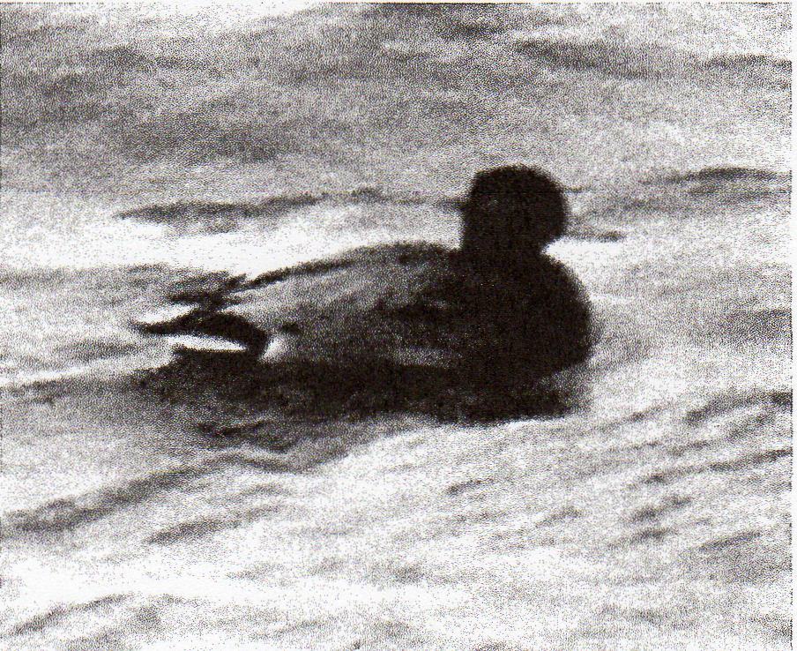
One of 10 different waterfowl hybrids identified in Oregon and Washington in winter 2008-2009, this Mallard x American Wigeon, photographed in the company of American Wigeon at Maryhill, Klickitat County 14 December 2008, was the Oregon & Washington region's first of this cross and one of two such birds found in Washington during the season. Though mostly Mallard-like in appearance, this bird showed extensive brown on the upper flanks, generally darker and more brownish flanks and back, no clear division between the brown on the breast and gray flanks, and long central tail feathers. The bill was a cold bluish gray. Photograph by David Irons.

312 NORTH AMERICAN BIRDS, Winter 2008-09

McWethy) and an early northbound bird at Royal L., Grant 27-28 Feb (RH) represent e. Washington's first winter season reports since 2004. Single Aleutian Cackling Geese were at Nisqually 11 Dec (SM) and near Sylvana, Snohomish 3 Jan (SM, SP); this subspecies (leucopareia) is extremely rare in Washington during winter, with virtually all records coming from the outer coast. Other Cackling subspecies continued to stretch their wintering range northward into the P.T. Groups of 92 taverneri and 5 minima near Sylvana 3 Jan (SM) and
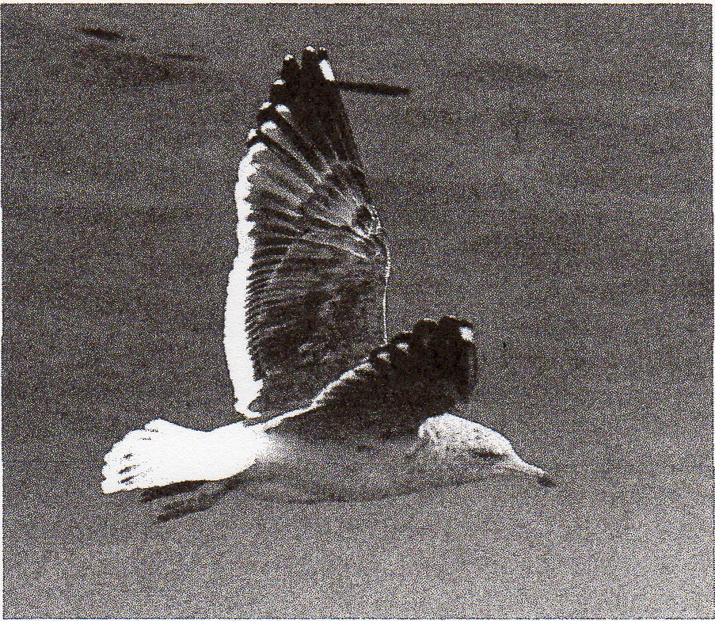
Slaty-backed Gulls are now detected annually in winter in the Oregon & Washington region. This third-cycle bird, photographed 20 February 2009, inhabited the Portland waterfront 24 January and later. It shows the diagnostic string of subterminal white spots on the fifth, sixth, and seventh primaries, as well as a light eye and extensive brown streaking and spotting on the head and underparts. Photograph by David Irons.

25 taverneri at Allen, Skagit 26 Dec (RM) were 50 km+ farther n. than flocks that reached the Snohomish R. in 2007-2008. Seventy-two southbound taverneri on Wickiup Res. 7 Dec was a record for Deschutes (CM, MM), while minima Cackling Geese in e. Washington lingered until 13 Dec, with 14 at McNary N.W.R. (DI, SM), and returned by 28 Feb, with 19 at Moses Lake (DS). A maxima Canada Goose at Blyn, Clallam 8 Feb provided w. Washington's first record since a failed introduction in the early 1970s (†SM, BW). This taxon may be a rare and, perhaps, regular migrant in e. Washington. A Dusky Canada Goose (B. c. occidentalis) at Cape Flattery, Clallam 17 Jan (BW, DWg) and 4 near Blyn 8 Feb (BW, SM) were well n. of this subspecies' winter range in sw. Washington. Three Brant strayed from salt water, including singles at Marymoor, King 5 Dec (J. Cohen), at Hillsboro, Washington 5-10 Dec (L. Humphreys), and Eugene 11 Feb (TM). Two Trumpeter Swans on Suttle L. Jefferson in Oregon's cen. Cascades 3 Jan were far from expected haunts (S. Shunk). Six wintering near Mosier, Wasco (SJ) were similarly unexpected. The bulk of the Region's wintering Trumpeter Swans inhabit the P.T., as evidenced by the 1,700 birds in nw. Snohomish and sw. Skagit 25 Jan (SM). A Bewick's Swan near Brady, Grays Harbor 18 jan-27 Feb was Washington's 11th (vt. BW, ph. DWg).
A slightly below-average 9 eastside Eurasian Wigeons were found away from favored Klamath. Hybrid wigeon were widely reported and are now so expected that they barely warrant mention. Two Blue-winged Teal graced the Elwha R. mouth, Clallam 11 Jan (BW); this species is less than annual in the Region during winter. Numbers of Cinnamon Teal wintering in w. Oregon have been on the rise for at least a decade. In addition to the traditional flock (40-55 birds) at Svensen I., Clatsop (MP), smaller groups—totaling more than 30 birds—were reported from several locales. Similarly, 11 Cinnamon Teal were at Ridgefield 12 Dec (DI, SM), with 4 remaining until 6 Jan (BF). A Northern Shoveler x Cinnamon Teal hybrid lingered at Ridgefield until 4 Dec (S. Carpenter). Reports of other hybrid dabbling ducks were plentiful, including the Region's 2nd Northern Pintail Wigeon at Edison, Skagit 28 Jan (RM, JB-P), the Region's first two Mallard x American Wigeons, near Maryhill, Klickitat 11 Dec (DI, ph. SM) and near Rexville, Skagit 22 Feb (ph. SM), and a Mallard x Northern Pintail at Samish Flats 28 Jan (RM). Washington's 3rd Baikal Teal graced Ridgefield 31 Jan (†C. Crawford, B. Crawford, ph. S. Kohl); all three records have occurred since 2004, coinciding with dramatic increases in this species' world population (Delaney and Scott 2006, Waterbird Population Estimates). A congregation of 17,000 Green-winged Teal at P.S.B. 3 Jan (SM, SP) eclipsed the prior Washington record. Eurasian Teal showed well, with 9 in Washington and 5 in Oregon; 4 were together at Edison 27 Feb (TA), equaling Washington's record count. Western Washington hosted all 4 Eurasian Teal x Green-winged Teal intergrades.
The 2,500 Canvasbacks at Wallula, Walla Walla 19 Jan (M&MLD) was Washington's highest count in more than four decades and the 2nd highest count ever; 2,800 Canvasbacks inhabited Turnbull N.W.R., Spokane during the winter of 1966-1967 (Birds of Washington 2005, Wahl et. al., eds.). Flocks of 79 Canvasbacks near Hillsboro 3 Jan (SS) and 63 at Vanport Wetlands 21 Jan (AF) were good counts for the W.V. The 1300 Ring-necked Ducks congregated at Capitol L., Thurston 7 Dec (SM, BT) made a w. Washington record. Three Tufted Ducks was slightly above average; singles enlivened L. Erie, Skagit 11 Jan-22 Feb (GB), Clatskanie, Columbia 13 Jan-7 Feb (D. Coggswell), and Portland 21 Feb+ (A. Clausing, m.ob.). A Tufted Duck x Greater Scaup along the Columbia R. between Rufus, Sherman and the John Day Dam 3 Jan+ (ph. CM, D. Faxon) also wintered here in 2007-2008; this cross first appeared locally in 2003, suggesting that one individual may be returning annually. A Surf Scoter at Haystack Res., Jefferson 1 Feb (CM) was noteworthy, as scoters of any species are not
annual e. of the Cascades during winter. Three eastside White-winged Scoters was exceptional; singles visited Sand Station, Umatilla late Nov-13 Dec (M&MLD, DI), Klamath Falls 12-13 Dec (DM), and L. Chelan, Chelan 2 Feb (DG). Two additional inland White-wingeds were at Hyatt L., Jackson 10 Dec (R. Ketchum).
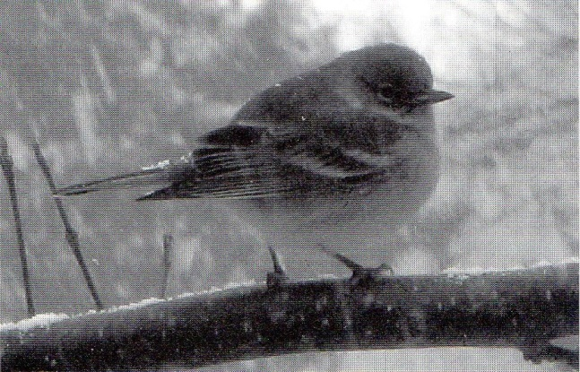
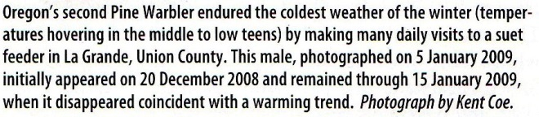

As is the norm, all 9 eastside Long-tailed Ducks were in Washington including 6 together at Wanapum Dam, Grant 28 Feb (DG, R. Meyers). A Common Goldeneye x Barrow's Goldeneye hybrid visited Bainbridge I., Kitsap 22 Dec (ph. BW); this cross has proven annual in the P.T. Historically not annual on the Oregon coast, male Barrow's Goldeneyes wintered again (8th year) at Astoria (L. Cain) and at Siletz

313 Volume 63 (2009) Number 2, Winter Season

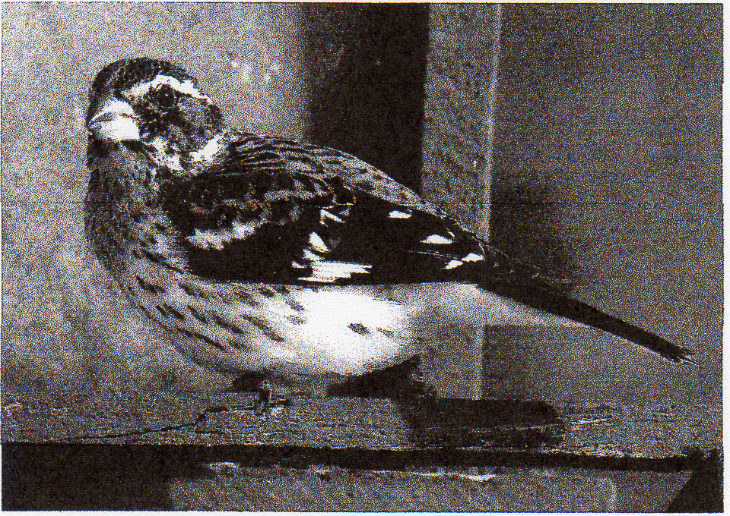
This first-year male Rose-breasted Grosbeak, photographed 21 February 2009 at Suncrest, Stevens County, Washington, braved much of the winter, remaining through 13 March. Photograph by Michael Woodruff.

Bay, Lincoln (C. Karlen, P Sullivan). Barrows are similarly unexpected in the interior lowlands of w. Oregon, thus one near Roseburg, Douglas 20 Dec (fide R. Maertz) and 3 at Eugene 29 Dec (P. Patricelli) were noteworthy.
Heavy southbound movements of Red-throated Loons persisted into early Dec; 5,000 flew past Boiler Bay 9 Dec (PP). A goodly 13 eastside Pacific Loons were all in Washington. Surprisingly, 11 were reported during Jan and Feb; this species is rare after mid-Dec e. of the Cascades. Another late inland Pacific was at Portland 12 Jan (AF). Eight Yellow-billed Loons were noted in w. Washington, including a maximum of 4 in Dungeness Bay, Clallam 15 Dec (CW, BL), while none was detected in Oregon. An extremely rare eastside Yellow-billed inhabited L. Chelan 21 Jan-2 Feb (fide MS, DG). This individual disappeared but was then relocated 60 km away at Chief Joseph Dam, Douglas 11 Feb (MS). A paltry 2 Clark's Grebes (5 is the norm) were detected in w. Washington this winter. A Clark's along the Columbia R. near Wallula Junction, Walla Walla 1 Jan (M&MLD) marks the 3rd consecutive winter that this species has been reported in e. Washington, where historically rare at this season.
The season's lone pelagic trip, out of Newport 21 Feb, encountered one Laysan Albatross and 10 Black-footed Albatrosses (GGi). The same trip tallied 104 Northern Fulmars, which went otherwise unreported. A Pink-footed Shearwater flew past Boiler Bay 8 Dec (PP), and 6 were off Newport 21 Feb (GGi). All-dark shearwaters seen from Boiler Bay 818 Dec were mostly identified as Short-tailed Shearwaters, including 8 there on 8 Dec (PP), while the 21 Feb pelagic encountered 13 Sooty Shearwaters (GGi). For the first time in seven winters, no tubenoses were reported in the P.T. An American White Pelican lingered on Upper Klamath L. through at least 6 Dec (D. Hewitt) and another was at Baskett Slough N.W.R. 25 Jan (J. Hayes). White Pelicans have wintered in the W.V. somewhat regularly over the past decade. Astounding numbers of Brown Pelicans carpeted the Oregon coast well into Dec. Morning flights produced counts of 2,000-4,000 birds at Boiler Bay 8-18 Dec (PP). Many of these northbound birds spent their days feeding and loafing at the mouth of Siletz Bay, where counts reached 2,000 birds in mid-Dec. Aside from a handful of reports of 4-8 birds during Jan, these pelicans were gone by late Dec. Though now annual in Oregon, Brown Pelicans remain rare in Washington during winter, so singles at Ediz Hook, Clallam 11-14 Jan (BW), at the Hoh R. mouth, Jefferson 17 Jan (BW, DWg), and at Westport 19 Jan (BT) were noteworthy. A tally of 52 at O.S. 27 Dec (fide D. Moore) was an extraordinary mid-winter tally. Equally remarkable were two reports of Brown Pelicans in the P.T., which has only a few antecedent winter records; one was at Pt. Wilson, Jefferson 5 Jan (B. Whitney) and another appeared near Olympia 14 Jan (C. Ceci). A single Brown Pelican strayed up the Columbia R. to Portland 31 Dec (fide HN). Most unexpected were 10 ad. Brandt's Cormorants actively tending nest sites in full breeding plumage near Westport 19 Jan (BT); the mean date for the arrival of older males on California's Farallon Is. is 21 Apr (Wallace and Wallace 1998, <http://bna.birds.cornell.edu>.
American Bitterns, once considered extremely rare Nov—Feb in e. Washington and ne. Oregon, have appeared in the Columbia Basin in three consecutive winters. One at Ladd Marsh 2 Jan (D. Bronson) was a winter first for Union, while 3 together at Columbia N.W.R., Grant 22 Feb (RH) were highly unusual. Considering the severity of the winter, one wonders if this trio was actually wintering or were very early migrants. Oregon's 6th Little Blue Heron, which first appeared at Neskowin, Tillamook in Nov 2008, wintered at nearby Siletz Bay (R. Lowe, m. ob.); this is the Region's 2nd winter record. Cattle Egrets lingered in w. Washington, providing the first winter season reports since 2005; singles were at Fir I., Skagit into early Dec (M. Axelson) and near Sequim through 15 Dec (DW). Oregon's lone Cattle Egret graced Monroe, Benton 6 Dec (D. Horgan, J. Hubbard). Two Black-crowned Night-Heron roosts at Moses Lake held 131 birds 13 Dec (DS); the only larger wintering population in the Region is in Klamath. It should be noted that these night-herons were preying on crayfish, which are abundant in Moses Lake, perhaps explaining the attraction to this locale.
Three Turkey Vultures soaring over Seattle 15 Dec (fide D. MacRae) and another at CleElum, Kittitas (TO) the same day were about six weeks tardy. As has become the norm, vultures wintered at several sites in the s. W.V. and sw. Oregon. Northbound birds began drifting into w. Oregon during late Jan, and the earliest eastside birds appeared at Prineville, Crook 15 Feb (N. MacDonald) and at Turnbull N.WR., Spokane 28 Feb (TO). An Osprey, now nearly annual during winter in Washington, visited Cowlitz, Lewis 22 Feb (D. Hayden). In addition to expected birds at Coos Bay and Eugene, single Ospreys graced Seaside, Clatsop 26 Jan (D. Bailey) and West-fir, Lane 31 Jan (C. Ferland); the latter site is at 365 m elevation in the foothills of the Cascades. Just 2 Red-shouldered Hawks were noted in sw. Washington, but one in nw. Washington, where still rare, wintered for the 3rd straight year at Kent (m.ob.). A Swainson's Hawk spent much of the season in Shillapoo Bottoms (ph. L. Topinka, BT); eight of the Region's 10 winter records have come in the past six years. In e. Washington, where Ferruginous Hawks are not annual during winter, 3 were detected 27 Dec-24 Jan. A rare dark-morph Ferruginous at Finley 13 Dec (WDR) was doubly surprising; this species is rare in the W.V. at any season. The Merlin of subspecies richardsoni at Alfalfa, Deschutes 6 Dec (PL) was a rare winter find; nearly all Regional records of this taxon have occurred during spring and fall migrations. Six west-side Gyrfalcons 9 Dec+ was slightly sub-par, while an impressive 7 were noted on the east-side (all in Washington) 26 Dec+. Prairie Falcons showed well again on the westside, with 10 in Oregon and 2 in Washington. A rare coastal bird was at Norway, Coos 3-8 Jan and later (DI, TR).
It has come to light that a flock of 5-6 Sandhill Cranes has been wintering at Frenchman Wildlife Reserve, Grant for at least five years (fide RH). This season, 10-12 Sandhills were in this area throughout the season (RH); cranes are typically less than annual in e. Washington during winter. A late flock of 55 at Royal Camp, Grant 4 Dec (RH) apparently departed before the season's first major cold front hit the Region 10 days later. Northbound flocks were widely reported over w. Oregon 24-27 Feb.

314 NORTH AMERICAN BIRDS, Winter 2008-09

SHOREBIRDS THROUGH WOODPECKERS
Now expected, 3 Lesser Yellowlegs spent the season in w. Oregon, where formerly absent during winter. Another Lesser, near Vancouver, Clark 12 Dec (SM, DI), marked the 9th consecutive winter that this species has occurred in Washington, quite remarkable, given that there was one such report during the 1990s. Rare away from the outer coast during winter, 2 Marbled Godwits were near Port Townsend, Jefferson 3 Dec-11 Jan (RM, TA, BW, JB-P). Coos Bay hosted a Red Knot throughout the season, just the 4th in the Region over the past five winters. Small flocks of Least Sandpipers totaling 29 birds inhabited W.W.R.D., the Yakima R. delta, Benton, and Soap L., Grant 1-13 Dec; these birds disappeared with the onset of subfreezing temperatures 14 Dec+. Ninety-two Leasts at Crockett L, Island 1 Feb (SM, D. Froelich) was an exceptional mid-winter tally for the P.T. Though Dunlin are now expected in e. Washington during winter, counts of 51 at W.W.R.D. 13 Dec (M&MLD, DI, SM) and 68 at Moses Lake 28 Feb were exceptional. One at Bend 6 Dec (PL) was the only report from e. Oregon. A Ruff at Coos Bay 30 Nov-13 Dec (RHo, TR) was the Region's 6th in winter; incredibly, four of the antecedent reports occurred during the winter of 2002-2003. Short-billed Dowitchers tarried into Dec in both states, where less than annual in winter. One at Samish Flats 9 Dec was Washington's first in winter since 2000 (MB), and another frequented Coos Bay 9-14 Dec (†R). Six Long-billed Dowitchers at Bend 9 Dec (PL) were presumed tardy migrants; this species rarely winters on the eastside. Perhaps expected given the concentrations of pelicans described above, hundreds of Heermann's Gulls lingered into mid-Dec along the Oregon coast; 300 at Boiler Bay 9 Dec (PP) was the high count. The latest were at Newport and Boiler Bay 21 Dec (WH, PP). One at Seaside, Clatsop 25 Feb (DB) likely wintered, as northbound Heermanns rarely reach the Region before late Apr. Twelve Mew Gulls scattered across e. Washington 13 Dec-22 Feb was above average. A single Mew visited Klamath Falls' L Ewauna 21 Feb (KS); they are almost annual at this site. Single Lesser Black-backed Gulls, annual in e. Washington since 1998, enlivened Leslie Grove Park, Benton 1 Jan (†NL) and the W.W.R.D., Walla Walla 15 Jan (†M&MLD); a few returning birds likely account for most, if not all, of these records. Since 2002, Slaty-backed Gulls have appeared annually in the Region Nov—Apr; Washington's 16th was at Everett 26-28 Dec (S. Atkinson) and Oregon's 12th, a third-cycle bird, resided at Portland 24 Jan+ (ph. G. Canterbury, ML, m.ob.). An ad. Western Gull was at McNary Dam 13 Dec (DI, SM); Westerns are detected annually along this section of the Columbia R. but are quite rare elsewhere on the eastside. We recommend caution when identifying apparent Westerns far inland, as many are likely Western Gull x Glaucous-winged Gull hybrids. Glaucous Gulls showed spectacularly, with 55 in the Region; observer effort and expertise surely explains the increasing reports of this species. All 24 Oregon birds were on the westside, including up to 9 around Newport Jan—Feb (WH), while 11 of Washington's 31 Glaucous were e. of the Cascades. A Glaucous Gull x Herring Gull hybrid was noted at Sequim 8 Feb (ph. SM, BW); this hybrid is not identified annually in Washington.
Oregon's 7th Thick-billed Murre was at Boiler Bay 15 Dec (†PP), while Washington's 18th drifted past Pt. No Point 12 Jan (†VN). A Washington record 1,350 Marbled Murrelets winged past Pt. Wilson, Jefferson during a one-hour period 8 Feb (BW, SM). Similarly, 600 Ancient Murrelets seen from Boiler Bay 16 Dec (PP) was an Oregon record. Single Cassin's Auklets, very rare for the P.T., were off of Bainbridge I., Kitsap 6 Dec (BW, GG, DW) and near Pt. Defiance, Pierce 20 Dec (CW). Though scarce inshore during winter, Cassin's are abundant offshore, as evidenced by 2,000 out of Newport 21 Feb (GGi). A flight of 6,000 Rhinoceros Anklets at Boiler Bay 9 Dec (PP) was an exceptional winter count.
A recent clearcut near Pilchuck, Skagit hoarded all 4 westside Snowy Owls 28 Feb (S. Aslanian). Ten eastside Snowies, 8 in Washington and 2 in Oregon, was about normal for a non-invasion year. Northern Hawk Owls graced the Columbia Basin for the 2nd consecutive winter. One hunted a residential driveway along Buzzard Lake Rd., Okanogan 15 Dec (†Gordon Kent); another, discovered near Bridgeport, Douglas 13 Jan (MS), disappeared briefly and then reappeared 3 Feb near Mansfield, Douglas, where it remained through the season (SP, MS). Three Northern Pygmy-Owls were noted away from forested areas in the Columbia Basin, where not detected annually; singles were at Coulee Dam, Grant 2 Jan (RF), Grand Coulee, Grant 26 Jan (G. Sheridan), and Vantage 15 Feb (D. Hayden). Individual Burrowing Owls returned and wintered again s. of Corvallis (M. Cutler) and e. of Peoria, Linn (RC); the latter bird was found dead in mid-Jan. The W.V. averages 2-3 per winter. The Great Gray Owl that frequented the outskirts of Colville, Stevens 14-18 Jan (W. Current, TO) was far from normal haunts. A group of 12+ Short-eared Owls roosting at Finley's Prairie Overlook restoration area 28 Dec (L. Millbank) was encouraging; wintering numbers of this species have been declining in the W.V. Anna's Hummingbirds again attempted to winter in e. Washington. One remained at Canyon Terrace, Benton through 24 Dec (fide NL), and 3 w. of Yakima persisted to 28 Dec (fide DG). All four disappeared when temperatures dropped, while another Anna's survived the season at Balfour Park, Klickitat (C. Flick). For the first time since 2000-2001, there were no mid-winter reports of Selasphorus hummingbirds. As has become the norm, the earliest northbound Rufous Hummingbirds appeared during the last week of Jan; one at Roseburg 28 Jan (R. Maertz) was slightly early for sw. Oregon, while another male at Everett 29 Jan (SM) was about four weeks early for the PT.; arrivals across the Region appeared 21-26 Feb. No Williamson's Sapsuckers were reported from Washington, where they have been nearly annual during winter since 1998. However, 3 were detected in Oregon 13 Dec—Jan. A male Yellow-bellied Sapsucker at Grants Pass, Josephine 20 Dec (M. Klem, ph. DV) and a female at Baskett Slough N.W.R. 16 Feb (MS et al.) were in w Oregon, where nearly annual in winter. Rare w. of the Cascades at any season, a Red-breasted Sapsucker x Red-naped Sapsucker hybrid enlivened Marymoor Park, King 29 Jan (ph. RM, MH); in recent years, westside birds initially reported as pure Red-napeds have often proved to be this cross. Red-breasted Sapsuckers are quite rare in ne. Oregon, so 2 there during the same winter bordered on astonishing. One was found on the Wallowa County C.B.C. 14 Dec Q. Hohmann). Another, seen repeatedly at La Grande, Union 23 Dec-2 Feb (†DT), had plumage consistent with the s. subspecies daggetti, whose breeding range extends only as far n. as sw. Oregon; eastside Red-breasted Sapsuckers are typically assigned to the more northerly ruber.

FLYCATCHERS THROUGH FINCHES
Eight Say's Phoebes 1 Dec—mid-Feb represented a typical haul for w. Oregon; as expected, 3 wintered at Cape Blanco, where annual (†JW). Single Tropical/Couch's Kingbirds lingered at Cape Blanco through 4 Dec (†JW), Mt. Vernon, Skagit through 18 Dec (B. Hamblin), and Brookings through 8 Dec (DM), furnishing just the 9th-11th winter records for the Region, all but two since 2001; calls heard from the Washington bird confirmed that it was a Tropical. The N.S.C.B. Scissor-tailed Flycatcher, reported in our fall column, persisted just long enough to yield the Region's first winter season record, remaining there 24 Nov-3 Dec (TR).
Steller's Jays rarely stray into the lower Columbia Basin, making one at Moses Lake,

315 Volume 63 (2009) Number 2, Winter Season

Grant 27 Dec-9 Jan (H. Hutshell, DS) quite noteworthy. It was a non-invasion year for Blue Jay, with just five reports, all but one from Washington; the lone westside bird spent the season at LaConner, Skagit (m.ob.). Though Western Scrub-Jays continue to expand into the Yakima Valley, with about 15 reports this period, none were reported e. of Yakima for the first time in several winters; the extremely harsh winter may have temporarily halted this advance. A Dec—Jan mini-irruption of Clark's Nutcrackers was confined to e. Washington, with birds appearing in several canyons along the s. side of the Columbia R. from the Spokane R. mouth, Lincoln to Brewster, Okanogan. Hawk Creek, Lincoln hosted 120 on 28 Dec (MW), while nearby Mill Creek Canyon; Lincoln had 27 on 28 Jan (F. Haywood). Another stray nutcracker was along the Little Spokane R., Spokane 11 Jan (MW), and 25 visited Central Ferry Canyon, Douglas 25 Jan (RH).
Consistent with the past few years, but about two weeks earlier than the long-term average, northbound Tree Swallows arrived in both states by 20 Jan. Three Barn Swallows at McNary Darn, Umatilla 13 Dec (DI, SM) were the season's only late southbound birds. Yet another mid-winter pulse of Barn Swallows in the Region generated reports of 26 birds (19 in Washington, 7 in Oregon) 14-23 Jan; these numbers were a shadow of those produced by previous winter flights (2002-2006). Though the causes of these mid-winter events remain a mystery, weather appears to have played a role this season. The incursion occurred on the heels of the season's only major subtropical rain event (often referred to as a "Pineapple Express"). As usual, there were no reports of Barn Swallows in the weeks immediately before or after this influx. After a minor fall irruption, 13 Mountain Chickadees were noted in w. Washington 20 Dec-14 Feb. Only one, at Hoquiam, Grays Harbor 27 Dec-2 Jan (R. Sullivan et al.), was w. of the P.T. Aside from some altitudinal movement, Boreal Chickadees are considered non-migratory in the Region. Hence, the presence of 4 more than 30 km from known populations, at Thomas Lake Campground, Stevens 30 Jan (K. Thorburn), perhaps suggests the expansion or irruption of yet another montane species. Bewick's Wrens continue to stretch their range eastward, primarily along riparian corridors. A Christmas count in Wallowa found its first ever on 14 Dec, while a count in neighboring Union detected a record-tying 9 Bewick's on 4 Jan (fide DT). A Swainson's Thrush still at Portland 16 Dec (ph. SF) appeared to have an injured wing; though often reported, this species is extremely rare in the Region Nov—late Apr. Surveys of an American Robin roost near Naches, Yakima produced tallies of 92,633 and 98,581 birds on successive evenings 14-15 Feb (J. Kozma, SDs). Though impressive, these counts are not quite half of the Region's published record: 200,000 at Union Gap, Yakima 15 Mar 2002.
Following two consecutive sub-par winters, 7 Northern Mockingbirds was near normal; one near Vancouver, Clark 29 Jan (E. Elias) was the lone report from Washington. A Brown Thrasher at Silverton, Marion 26-29 Dec (M. Schneider, ph./vt. T. Bray) was the first winter report since 1996; all but one of the Region's 13 winter records have come from Oregon. American Pipits are quite scarce on the eastside during winter; thus, flocks of 12 at Yakima 13 Dec (K. Turley) and 35 near John Day Dam, Klickitat 14 Dec (DL SM) were noteworthy. One was at Bennington L., Walla Walla 14 Dec (M&MLD); one wonders how these semi-hardies fared after daytime temperatures dropped into the teens on the latter date. Bohemian Waxwings made a strong showing in ne. Oregon, with several flocks of 100-300 birds reported from Union and Wallowa during Dec and Jan. A Bohemian at Sisters 13 Dec (S. Shunk) and 2 at Bend 23 Dec (PL) were in cen. Oregon, where barely annual. The lone w. Oregon report came from Portland 18 Dec. (P Newland, m.ob.). Bohemians have become increasingly rare in w. Washington of late, so 70 at Skagit W.M.A. 1 Jan (RM) were rather surprising; other sightings included one at Juanita Park, King 23 Dec (RM) and 2 at Renton, King 29 Dec (CW).
An Orange-crowned Warbler at La Grande 20 Dec-1 Jan (†DT), likely a winter first for Union, was described as the subspecies celata; the reported taxon is a presumed, but rarely documented, migrant through the Region. Washington's 6th winter Nashville Warbler enlivened Shillapoo Bottoms, Clark 12 Dec (DI, SM); though nearly annual during winter in Oregon over the past decade, the most recent Washington winter record was in 1993. Up to 8 Yellow-rumped Warblers, involving both subspecies, wintered at La Grande, where they have been recorded only twice in the 33-year history of the Union County C.B.C. (DT). The Yellow-throated Warbler that inhabited Langlois, Curry 13-15 Jan (†JW, ph. L. Miller) was the first in the Region since 2005 and 7th overall; one at Seaside, Clatsop 29 Jan-5 Feb 2005 and one at Twisp, Okanogan 21-22 Dec 2001 are the only other winter records. Few would have predicted that the Region's 2nd Pine Warbler would be found frequenting a La Grande feeder 20 Dec (M. & S. Daugherty ph. K. Coe, †DT). This bird endured an extended period of sub-freezing temperature and then abandoned the feeding station when the freeze abated in early Jan; it was last seen 15 Jan. The lone antecedent record involved an imm. at Harbor, Curry 23 Oct 1986. Five of the season's 7 Palm Warblers wintered along the s. Oregon coast, where annual. One lingering at Renton to 4 Jan (RM) was believed to be a returnee, while another found at Peoria, Linn 9 Jan remained through the period (RC, m.ob.). Black-and-white Warblers appear in the Region about every other winter; this season's bird was at Aloha, Washington 28 Jan (†C. Blair). Rare during winter, one of the fall's 2 Northern Waterthrushes persisted at Skagit W.M.A. until 17 Dec (RM). An ad. male MacGillivray's Warbler at Bennington L., Walla Walla 12 Dec (†Nate Drumheller) was record late for Washington by eight days. The season's 5 Wilson's Warblers would have been inconceivable two decades ago, but this species is now annual during winter. One at Two Rivers Park, Benton 13 Dec (D. Rockwell, K. Burke) was just the 4th seasonal record for the eastside. Single Common Yellowthroats along the Oregon coast at Coos Bay 14 Dec (TR) and Astoria 20 Dec (L. Cain) were the only reports of the season; yellowthroats are rare but annual in the Region during winter. For the 11th consecutive year, a Western Tanager brightened the season. Surprisingly, this year's bird appeared on the eastside at Prosser, Yakima 1 Dec (S. Wierenga).
Increased observer effort in recent winters has consistently turned up small numbers of American Tree Sparrows in se. Oregon; 10 were at Summer Lake W.M.A. 16 Dec (JM), and 4 were at Malheur 20 Dec (fide S. Dowlan). One near Florence 15 Dec (J. Sullivan) provided the only westside report. A Chipping Sparrow at Madras, Jefferson 3 Dec (JM) was the first winter report from the east-side since 1998; there are fewer than five published winter reports from e. of the Cascades. Just 2 Chippings were in the WV, where up to 28 have been detected during recent winters. Clay-colored Sparrows visiting Langlois 4 Dec (†R), Brady, Grays Harbor 7 Dec (SM, BT), and Florence 28 Dec (fide AC) were all on the westside, where rare but annual. A northbound Sage Sparrow strayed to Ridgefield 23-26 Feb (S. Carpenter, ph. S. Nord), providing the 2nd winter record for w. Washington and just the 8th there at any season; the timing of this report coincides with their arrival on the eastside. Savannah Sparrows, which have only started wintering in e. Washington recently, continued to gain a foothold, with groups of 25+ at Yakima 13 Dec (K. Turley, E. Stepniewski) and John Day Dam 14 Dec (DI, SM). Another 8 were at the Winchester, Grant 30 Dec (RF). A flock

316 NORTH AMERICAN BIRDS, Winter 2008-09

of 100+ Savannahs near Airlie, Polk 11 Feb (J. Grier) made an exceptional winter count for the WV; these birds may have been early northbound migrants. With potential species status on the horizon, heightened scrutiny of Fox Sparrow has resulted in increasing detections of Red Fox Sparrows (iliaca/zaboria type). This season, 5 were well documented 13 Dec-23 Jan; one at Yakima 16 Dec (ph. AS) was the lone eastside report. Apparent altivagans Fox Sparrows at Alice Bay, Skagit 28 Dec (ph. JB-P) and at Hansville, Kitsap 6 Jan (BW) were a bit surprising, since the primary winter range of this enigmatic taxon lays well s. of our Region; altivagans are variously assigned to either the Red or the Slate-colored subspecies group, depending on the source. Sooty Fox Sparrows are poorly known e. of the Cascades but are likely somewhat regular there in small numbers. Single Sooties were reported from McNary Dam W.M.A. 13 Dec (DI, SM), Redmond 4 Feb (K. Owen), and Fort Rock, Lake 14 Feb (W. Parker). The mid-Dec cold snap produced a flurry of reports of Lincoln's Sparrows coming to urban and suburban yards and feeding stations in the WV; this species typically avoids areas of densely settled areas, and these birds disappeared with the return of normal temperatures. A near-normal 6 Swamp Sparrows were detected in w. Washington this winter, while close to 20 were reported from w. Oregon; the bulk of the Oregon sightings came from Coos, including 8 in the Coquille Valley 3 Jan (fide AC). The lone report from the eastside, where Swamps are less than annual, came from Mc' Nary Dam W.M.A. 13 Dec (DI, SM). Harris's Sparrow numbers approximated recent norms with 22 reported. Thirteen Golden-crowned Sparrows at McNary Dam W.M.A. 13 Dec (DI, SM) were near the e. limit of their winter range in the Region. The season's high counts for Lapland Longspurs came from Lummi Flats, Whatcom 2 Dec (M. Roening, J. Bird) and Floras L, Curry 16 Dec (TR), with both sites hosting 14 birds. Seven Laplands were at Coos Bay 14 Dec (fide TR); fewer than 20 were reported elsewhere in the Region. The 250 Snow Buntings near Enterprise 6 Jan (ML) was the only large flock reported.
The hatch-year female Pyrrhuloxia reported in our fall column remained at Peoria, Linn through the winter season (RC); the timing of this record, which fits the dispersal pattern recently described by Patten (2006, Dispersal and vagrancy in the Pyrrhuloxia. Western Birds 37: 37-44), and the age and sex of this bird strongly suggest wild provenance. Three Rose-breasted Grosbeaks graced the Region. Singles at Sequim, Clallam 19-28 Dec (ph. T. Cullinan) and Suncrest, Spokane 20 Feb-13 Mar (ph. MW) made just the 3rd and 4th winter records for Washington, while an imm. male at Brookings 24 Dec (DM) was about the 12th such record for Oregon. Single Black-headed Grosbeaks, at Eugene 1 Jan (B. Uhler, RR) and Foster, Linn (Betty Mankin), were equally unexpected. The gradual range expansion of Tricolored Blackbirds continues, and this species now winters annually in Washington, where it was unknown prior to 1998. One near Vancouver L., Clark 12 Dec (SM, DI) was the first there since Jan 2006; all previous w. Washington reports have come from this site. Eighty Tricoloreds were near favored Othello 27 Dec (RH), but few were noted there through the remainder of the season; this species first wintered in Adams in 2003. Groups totaling 6 birds were reported from two Walla Walla sites 15 Jan-1 Feb (M&MLD); Tricoloreds first appeared here during the winter of 2006-2007. A flock of 30 Tricoloreds near Cecil, Morrow 7 Jan (ML) was in an area with few previous reports, though they were detected nearby during the 1995-1999 Oregon Breeding Bird Atlas project. Four Rusty Blackbirds appeared in Washington, where nearly annual in winter. Both westside birds, a male 21-25 Dec and a female 3 Jan were at Sylvana, Snohomish (SM), while singles enlivened Wenatchee 21 Dec (J. Eldridge) and Turnbull N.W.R. 2 Feb (CC, N. Curry). A Great-tailed Grackle at Klamath Falls 20-26 Feb (DM, J. Van Moorhen) represents just the 3rd winter record for the Region. This species has wintered multiple times just across the California/Oregon border in Modoc, and spring birds, which are annual around Tulelake, CA, rarely arrive before May (fide KS). Now annual in winter, this season's Bullock's Oriole was at Astoria 19 Dec (S. Haller). An unidentified oriole at Keizer, Marion 5 Dec (B. Benin) was probably a Hooded.
Single Gray-crowned Rosy-Finches at Seattle 19 Dec (D. Hutchinson), at O.S. 27 Dec (CW, M. Pike), and at Semiahmoo Spit, Whatcom 5 Jan (M. Shimazu) were in the w. Washington lowlands, where not annual. For the 2nd time in three years, Pine Grosbeaks Irrupted into the Region, with nearly 800 individuals reported in e. Washington. Several flocks of 50+ graced Okanogan 30 Dec-22 Feb, highlighted by 100+ at Pearrygin S.P. 11 Jan (S. Lupson-Cook). Smaller numbers wandered into mostly treeless Whitman (the heart of wheat country) 11-22 Jan, with a high count of 15 at Palouse 11 Jan (C. Swift). Surprisingly, 8 birds near Joseph, Wallowa 9 Feb (JM) was highest count from ne. Oregon; deep snows rendered many traditional wintering areas inaccessible, leaving one to wonder how many grosbeaks went unseen. Pine Grosbeaks also showed well to the w. of the Cascades, particularly in Washington, where 33 were noted from nine locations 29 Dec-27 Feb. One at Mary’s Peak 5 Feb (WDR) and a small group on Saddle Mt. in early Feb (M. Drigiewicz) were extremely rare strays to Oregon's Coast Range. Sizeable flocks of Purple Finches enlivened the westside lowlands in both states. Ninety-five Purples at the Skagit W.M.A. 24 Dec (RM) edged past the prior Washington record; 91 were at this site on 15 Dec 2007. Three Purple Finches strayed e. of their normal haunts; 2 were at Moses Lake 23 Dec (DS), and another visited Central Ferry Canyon 25 Jan (RH). Photographs of another eastside Purple Finch, at Conconully, Okanogan 19 Feb (ph. RM), show a bird of the e. subspecies purpureus, a Regional first; this subspecies has also been documented in California. A Cassin's Finch at Portland 30 Dec (A. & C. Hinkle) marked the 3rd consecutive winter that this species has appeared w. of the Cascades. Sixty Cassin's at Fort Spokane 28 Dec (MW) were particularly surprising, given that there was only one other lowland report from e. Washington; one was at Moses Lake 23 Dec (DS). Red Crossbills were conspicuous along the cen. Oregon coast 24 Jan+ (m.ob.) but generally unreported elsewhere in the Region; from mid-Feb on, modest flocks began appearing in the s. WV, presaging a major spring influx (DI).
Mirroring Pine Grosbeaks, Common Redpolls

SA Prior to late Dec. Washington's yearlong influx of White-winged Crossbills had been mostly confined to montane and forested habitats where this species is to be expected. Thereafter, no fewer than 83 birds strayed into corners of the Columbia Basin far removed from mountains and forests, making appearances in locales where they were unprecedented or nearly so; 16 crossbills at Lyons Ferry Park 16 Jan (MH, T. Mansfield) and another 12 at Pomeroy (MH) were firsts for Franklin and Garfield, respectively. Additionally, 18 were along. Pullman Rd, Whitman 22 Jan (MW), 9 were at Coulee City, Grant 8 Feb (DS), and 24 were at Spangle, Spokane 11 Feb (MW). These birds often appeared in towns and parks where non-native ornamental plantings of spruces and Douglas-firs provided bumper cone crops. Modest flocks (20 or fewer) appeared at several more-expected sites in the Okanogan Highlands and the foothills of the Selkirk Mts.; 60 at Conconully, Okanogan 19 Feb (BM) represented the largest group from this area. Oregon's reports all came from Union and Wallowa, with a high count of 15 at Joseph, Wallowa 15 Feb (T. Shelmerdine). Four White-winged Crossbills near Anacortes, Skagit 18 Jan-7 Feb (ph. T. Link)) were rare for the westside lowlands.

317 Volume 63 (2009) Number 2, Winter Season

duplicated their excellent 2006-2007 showing. Congregations of 500 along Chewuch Rd., Okanogan 24 Dec (SS), 420 at Conconully, Okanogan 2 Feb (D. Wheelan), plus groups of 200 at Enterprise, Wallowa 17 Jan (C. Karlen, P. Sullivan) and the Little Spokane R., Spokane 28 Feb (B. Siems) were exceptional. Redpolls are less than annual in the WV, thus one at Portland 22 Dec+ (D. Mandell) was noteworthy. On the surface, the flock of 800-1000 Pine Siskins at Lincoln City 20 Dec (PP) sounds amazing. Incredibly, the Regional record is ten times this tally; 10,000 siskins were at Harts Pass, Okanogan 1 Aug 1996. A Lesser Goldfinch at the Grande Ronde R. mouth, Asotin 10 Jan (TG) and 2 near Clarkston, Asotin 20 Feb (TG), were away from their traditional Klickitat haunts.

Contributors cited (subregional editors in boldface): Tom Aversa (Washington), David Bailey, Range Bayer (Lincoln), Gary Bletsch, Joel Brady-Power, Mary Breece, Randy Campbell, Alan Contreras, Craig Corder (Spokane), Scott Downes, Shawneen Finnegan, Bob Flores, Andy Frank, Ron Friesz, John Gatchet, Chuck Gates (Crook), Greg Gillson (Washington, The Bird Guide Pelagics), Denny Grandstrand (Yakima), Terry Gray, Randy Hill, Michael Hobbs, Wayne Hoffman, Rich Hoyer, Stuart Johnston (Klickitat, Hood River) Bruce Labar, Margaret LaFaive, Bill & Nancy LaFramboise (lower Columbia Basin), Peter Low, Dave Menke, Judy Meredith, Ryan Merrill, Tom Mickel (Lane), Craig & Marilyn Miller (Deschutes, Jefferson), Steven G. Mlodinow, Harry Nehls (Oregon), Vic Nelson, Tim O'Brien, Clarence & Marilyn O'Leary (Grant), Mike Patterson (Clatsop), Phil Pickering, Steve Pink, W. Douglas Robinson (Benton, Polk), Tim Rodenkirk (Coos, Curry), Stefan Schlick, Kevin Spencer (Klamath), Meredith Spencer, Andy Stepniewski, Bill Tweit, Dennis Vroman (Josephine), Dan Waggoner (DWg), Terry J. Wahl, Doug Watkins, Michael Woodruff, Charlie Wright.

Spring Migration, 2009

Oregon/Washington Region

David Irons
Douglas Schonewald
Brad Waggoner

Following back-to-back seasons colored by mega-rarities and crazy weather, this season seemed uneventful. There were no Regional firsts, no flooding, no record snows, and no weather that produced epic fallouts, yet many seasonal records were rewritten. With all-time high counts in seemingly every paragraph, we are left to wonder: Why? Are we simply finding more birds? Are we getting better at collecting reports? Are there more birds than there used to be? The simple answer to these questions is surely yes.
The pool of talented observers has never been deeper, and the Internet now allows us to share sightings and, more importantly, new and exciting places go birding—instantly. Indeed, many birds' ranges are expanding in the Region, notably Glossy and White-faced Ibises, Red-shouldered Hawk, Black Phoebe, Western Scrub-Jay, Bewick's Wren, and Lesser Goldfinch. For other species, such as Snow Goose, Baikal Teal, and both American White and Brown Pelicans, increasing global populations seem to correlate with greater numbers and more widespread distribution in our states.
Collectively, these factors make our Region a challenge and a joy to chronicle as we face the daunting task of explaining why. Our commentary is occasionally speculative, and one might argue that the sample size of a single season's data is too small to yield firm conclusions. However, the accretion of our individual observations over several years and even decades allows us to identify and discuss the real changes that are happening before our eyes.

491 Volume 63 (2009) Number 3, Spring Migration

In this regard, we believe that this journal has no peer.
Because this is a human endeavor, we are occasionally inspired to acknowledge the invaluable contributions and, unfortunately, the departures of those who make these seasonal summaries possible. It is with great sadness that we report the unexpected passing of Laura Dowlan, the wife of long-time Oregon contributor Steve Dowlan. With an understandably heavy heart, Steve has chosen to return "home" to Pennsylvania to be nearer extended family.
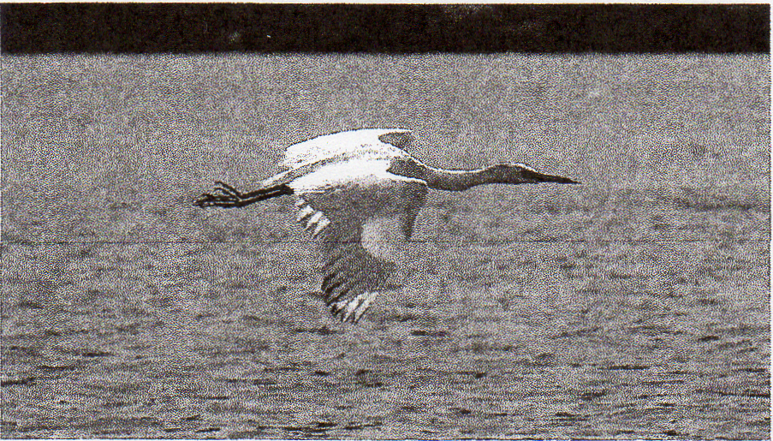
After first appearing about 32 kilometers to the north at Neskowin, Tillamook County, Oregon in November 2008, this immature Little Blue Heron took up residence at Siletz Bay, Lincoln County, where it remained through the spring season. In this photograph, taken 4 April 2009, it is beginning to show some dark feathering on the head. Photograph by Bill Medlen

During his years in Oregon, he was tireless in exploring and then reporting on his home patches, first in eastern Marion County and then northern Harney County. His discoveries taught us much about these areas. Steve's contributions to this journal and his companionship in the field will be greatly missed.
Additionally, this season marks the one-year anniversary of Steve Mlodinow's retirement as our senior Regional Editor. A year ago, we were scrambling to cobble together our first report. Today, the high standards that Steve created during a ten-year run at this Region's helm continue to shape the way we craft our reports. Though his name no longer appears in the byline, his ongoing input and editorial suggestions invariably help to improve our final report. We were remiss in not giving him a proper send-off a year ago, perhaps because as the torch was being passed he never stopped supporting us with his encyclopedic knowledge of the Region's birdlife and critical eye for details. For these contributions and his enduring friendship, we are most grateful.

Abbreviations: Ankeny (Ankeny N.W.R., Marion); Baskett Slough (Baskett Slough N.W.R., Polk); E.E.W. (E. E. Wilson W.M.A., Benton); Finley (William L. Finley N.W.R., Benton); F.R.R. (Fern Ridge Res., Lane); N.S.C.B. (N. Spit Coos Bay, Coos); O.S. (Ocean Shores, Grays Harbor); P.N.P. (Pt. No Point, Kitsap); P.S.B. (Port Susan Bay, Snohomish); P.T. (Puget Trough); Ridgefield (Ridgefield N.W.R., Clark); W.W.R.D. (Walla Walla River Delta, Walla Walla). "Eastside" and "westside" indicate locations e. and w. of the Cascade Crest, respectively.

WATERFOWL THROUGH RAPTORS
The 10,000 Greater White-fronted Geese resting on Tillamook Bay 28 Apr (TJ, OS, JW) made a westside spring record; 9,690 passed Cape Flattery 26 Apr 1996. Once scarce away from the Klamath Basin, increasing numbers of Greater White-fronteds are now being detected elsewhere on the eastside. The 2,000 at McNary N.W.R. 8 Mar (BD) was e. Washington's 2nd highest tally ever. A Tule Greater White-fronted Goose (subspecies gambelli) at Othello 2 Mar (RH) was noteworthy, as this taxon is rarely identified (though likely regular) in Washington. An apparent Greater White-fronted Goose x Cackling Goose hybrid inhabited Baskett Slough 24 Apr (WH). The Emperor Goose that wintered at Bandon remained through 4 Apr (H. Schubothe). A blue-morph Snow Goose at County Line Ponds, Grant 21 Mar (M&MLD) and 2 at Sprague L., Lincoln 21 Mar-3 Apr (CC, KK) adds to about 12 prior records from e. Washington. This morph has become regular in Washington since it began breeding at Wrangel I., Russia in 1995. The only westside Blue was a modestly late bird at Samish Flats, Skagit 19 Apr (J. Meyer). Large flocks of Snow Geese are now annual at McNary N.W.R.; 1,800 gathered there 8 Mar (BD). Singles at Slavin Ranch, Spokane 14 May U. Isacoff) and Wanapum S.P., Kittitas 16 May (M&MLD) were nearly a month late. Two Snows appeared along the s. Oregon coast, where less than annual; singles visited N.S.C.B. 22 Apr-1 May (J. Metzler, DL) and Cape Blanco 25 Apr (†JW). Four westside Ross's Geese, 14 Mar-1 May, approximated recent spring averages; another single, present continually at Poulsbo, Kitsap since Dec. 2000, finally disappeared 8 Mar (fide BW). Outstanding numbers of Ross's graced e. Washington, where no fewer than 67 were reported 1 Mar-15 May. On 30 Apr, the 2nd and 3rd largest flocks ever reported from e. Washington-36 and 24 birds, respectively—visited Philleo L., Spokane (RN). Now annual during spring in Harney, 4+ blue-morph Ross's frequented the Burns area 14 Mar-10 Apr (SD. R. Vetter). A Red-breasted Goose of unknown provenance consorted with Cackling Geese at Finley 11 Apr+ (R. Armstrong, m.ob.). Single "Gray-bellied" Brant at Long Beach, Pacific 12 Apr (JG), Ten-mile Cr., Coos 19 May (HH), and Yaquina Head, Lincoln 30 May (WH), were rare strays from their expected haunts in the P.T. Single Trumpeter Swans tarried at Horn Rapids S.P. 1-20 May (B&NL), P.S.B. 17 May (SM), and Crocker L., Jefferson 22 May (MB, KK); this species normally departs by mid-Apr. Tundra Swans also dawdled, the latest being 3 at Midway Beach, Pacific 21 May (E. Huston). A Bewick's Swan, first detected at Brady, Grays Harbor in Jan, remained through 24 Mar (KB); this subspecies has occurred in Washington in five of the past six years.
Forty-nine Eurasian Wigeons in e. Washington 8 Mar-8 May obliterates the previous seasonal record (34 in 2006). Twelve at Tyson Ponds, Walla Walla 13 Apr (M&MLD) is the largest flock ever recorded in that subregion. Yet another Mallard x American Wigeon hybrid appeared in Washington; this one, near Port Townsend, Jefferson 14-19 Apr, was just the 3rd for the Region, all since Dec 2008. The Mallard x Gadwall hybrid ("Brewer's Duck") that enlivened Randall Park, Yakima 8 Mar was nearly as rare (ph. DG). The Mallard x Northern Pintail near Kent, King 1 Mar (EH) and a Cinnamon Teal x Blue-winged Teal hybrid at Burns, Harney 3 Apr (CM) were more expected; these crosses are detected annually in the Region. Washington's 4th Baikal Teal, at L. Terrell, Whatcom 17 Mar (ph. P. Woodcock), was the 3rd in the past 11 months; seven of the Region's eight records have come since 2004. Eurasian Teal showed well with 14 on the westside (7 per state) and 3 on the eastside 1 Mar-21 Apr. All 8 Eurasian Teal x Green-winged Teal inter-grades were on the westside, 7 of these in Washington. Four Tufted Ducks was about average, with one making its 4th consecutive spring appearance at F.R.R. 11-26 Apr (A. Heyerly, m.ob.). All three scoter species appeared inland, where very rare in spring; Portland hosted a Surf Scoter 3 Apr (AF), and a White-winged Scoter was on L. Chelan, Chelan 14 Mar (W. Weber), only the 10th in spring for e. Washington. Three White-wingeds flew up the Columbia R. past Ridgefield 25 Apr (BF). A Black Scoter at Wander-mere L., Spokane 8 Mar (†TL) furnished just the 2nd spring record and 12th overall for e. Washington. Though annual in spring on the eastside, 8 Long-tailed Ducks was a seasonal record; these included 6 at Wanapum Dam 1

492 NORTH AMERICAN BIRDS, Spring 2009

Mar (J. Higbee), plus late singles at Klamath Falls 29 Apr (JVM, D. Stein) and Liberty L., Spokane 2 May (MW et al.). An assemblage of 400 migrant Ruddy Ducks on Siltcoos L., Lane (AC, DF) was among the highest counts ever along the Oregon coast. Two Red-throated Loons were at Sacajawea S.P., Franklin 27-28 Mar (R. Taylor, NL); prior to 2000, there were just four Mar—May records for e. Washington, where now annual in spring. A spectacular loon flight at Boiler 24 Apr produced the best spring tallies since 2002; 4,000 Red-throated Loons more than doubled recent high counts, and the passage of 65,000 Pacific Loons included peak pulses of 2,000 per minute (PP). Four Pacifies were detected in e. Washington 14 Mar-18 Apr; the earliest remained at Wanapum Dam, Kittitas/Grant through 16 May (SDo, AS). All 4 Yellow-billed Loons were in Washington; a long-staying eastside bird at Chief Joseph Res., Douglas was last seen 10 Apr (MS), and the latest remained at Sekiu, Clallam through 13 Apr (fide CW). Westside reports of Clark's Grebes were pedestrian away from F.R.R.; 6 were in Oregon (5 along the coast) 19 Apr-25 May, and 3 were in Washington 4-25 Apr.
Good offshore coverage produced 7 Laysan Albatross reports in Oregon waters; an 18 Apr pelagic trip to Perpetua Banks, Lincoln encountered 2 (GG), and 5 were seen from cruise ship 8 May (DI, JW et al.). The 18 Apr pelagic also found 250 Black-footed Albatrosses (GG). The high count of Northern Fulmars, 300, came from Boiler Bay 12 May (PP), while offshore numbers were paltry. Though now expected during spring, the 35+ Murphy's Petrels seen 80 km offshore during the 8 May cruise (DI, JW et al.) constituted a record for the Region; 3+ were encountered in each of Oregon's seven coastal counties, including 12 in Coos. Two more Murphy's were off Pacific 8 May (DI, JW et al.). Some aboard the cruise ship had scope views of a bird believed to be a Solander's Petrel off Lane, OR 8 May (†DI, †SM, B. Hinrichs et al.); though well-known from the n. Pacific, there are no accepted records from U.S. waters. Eight Mottled Petrels were tallied over the Nitinat Canyon and Juan de Fuca Canyon 48-71 km off Clallam, and unidentified white-footed Shearwaters were seen from
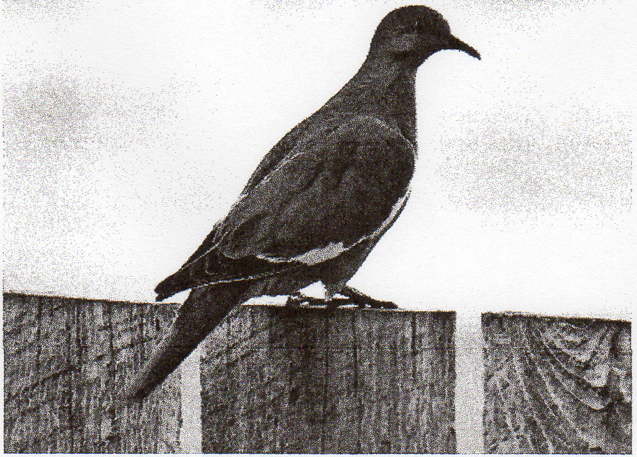
Formerly extremely rare in the Pacific Northwest, White-winged Doves are now detected annually. This individual, photographed on 30 May 2009, spent several days at Frenchglen, Harney County, Oregon. Photograph by Johnny Powell.

shore in both states, with 21 reported 6-12 May (RM, PP); nearshore reports are rare in spring. The 10,000+ Sooty Shearwaters seen from Boiler Bay 12 May (PP) was the season's high count. Sixteen Manx Shearwaters, 6 Mar-21 May, was a seasonal record; all but one of 7 in Washington were offshore, while 6 of 9 Oregon birds were seen from land. Offshore numbers of Fork-tailed Storm-Petrels were low, with only 88 off Oregon during 8 May (JW); singles were noted from Cape Disappointment, Pacific 20 Mar (MW, CW) and Boiler Bay 7 May (PP).

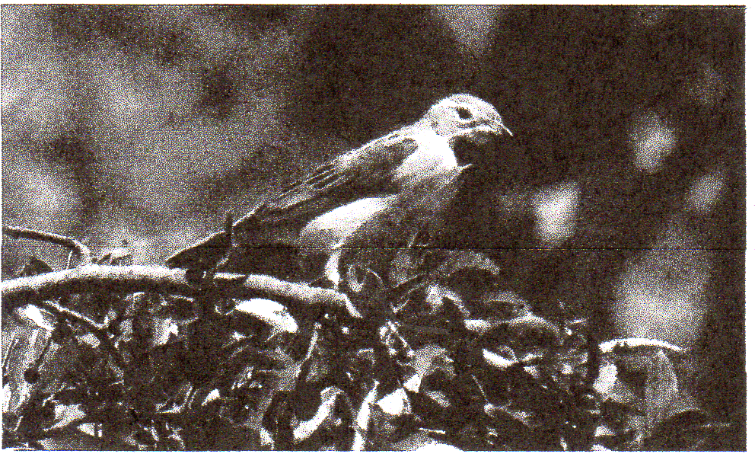
This first-year male Dickcissel that appeared near Grants Pass, Josephine County, OREGON 27 May 2009 provided the first spring record in the Oregon & Washington region since 1995. Photograph by Phil Hicks. [Oregon is indeed the correct location, Phil Hicks]

Nearly 100 American White Pelicans wandered to the westside, mostly during May. Twelve at Aberdeen, Grays Harbor 27 May (D. Moore) were among 21 that reached the outer coast, where they were once mega-rare but are now nearly annual; A Brown Pelican at Winchester Bay, Douglas 6 Mar (RN) preceded the first northbound flocks by 6 weeks. May—Jun Brown Pelican records have been increasing since 2006 in the PT., where formerly rare before mid-Aug, This season's reports included one at Blaine, Whatcom 30 Apr-4 May, one at Point Defiance, Pierce 7-18 May (B. Owens), and an impressive 22 near Seattle 15 May (M. Bond). The Little Blue Heron discovered at Siletz Bay, Lincoln Dec 2008 remained through 7 Apr (RL, ph. B. Medlen). Single Cattle Egrets at Boiler Bay 17 May (WH) and Diamond, Harney 23-25 May (RH, m.ob.) were the Region's first spring birds since 2005. Two Black-crowned Night-Herons at Newport 2 Apr (T. Snetsinger) were likely migrants, but to where? By pure chance, Oregon's 4th Glossy Ibis was documented when the photographer tried out his new camera on a flock of ibis at Malheur 23 May (ph, D. Baccus); this species has appeared annually since 2006 in se. Oregon. White-faced Ibis again showed well away from breeding sites in se. Oregon; 31 were reported from four w. Washington locales 12-18 May, and nearly 100 visited w. Oregon 9 May+, including flocks of 35+ at Sauvie I. 22 May OW) and 40 at F.R.R. 24 May (D. Brown). Eastern Washington, where ibis are now annual, saw a modest incursion, with 19 birds at four locations 20-30 May.
A Broad-winged Hawk was w. of Thorp, Kittitas 3 May (†TB), and another soared over Bandon 8 May (†JW); the former was Washington's 16th, while Oregon has 25+ reports. A record 7 Swainson's Hawks passed through w. Washington 1-17 May, including 3 over Skagit W.M.A. 2 May (GB, B. Kuntz); this species is still not annual in w. Washington. Single Rough-legged Hawks near Brownsville, Linn 2 May (J. Harding) and Pendleton, Umatilla 9 May were a month tardy. A Golden Eagle just e. of Reedsport, Douglas 16 May (JB) was in the coastal lowlands, where less than annual. This season's "Prairie" Merlins (subspecies richardsoni) were near Edison, Skagit 1 Mar-15 Apr (ph. RM, TA) and Othello 1 Mar (†TO); this taxon is now reported annually in the Region. All 3 Gyrfalcons were in e. Washington 1-23 Mar.

SHOREBIRDS THROUGH WOODPECKERS
The Klamath Basin is proving to be an important stopover for northbound Black-bellied Plovers; 500 near Bonanza, Klamath 26 Apr (JVM) replaced the previous eastside record

493 Volume 63 (2009) Number 3, Spring Migration

(358) set just last spring at nearby White Lake. Black-bellieds remain a novelty elsewhere e. of the Cascades, with 8 reported from four Washington locations 8-25 May providing the only other reports. Golden-plovers were again scarce; unidentified singles flew past Boiler Bay 22 Apr and 9 & 10 May (PP), while 2 Pacifics at O.S. 25 Apr (K. Carlson) constituted the lone Washington report. A Snowy Plover at Crockett L., Island 27 May (RM) was just the 5th for the P.T. but the 4th there since 2003; aside from one Sep record, all have been in May. Rare, but now annual in w. Washington, 7 Black-necked Stilts were tallied 25 Apr-11 May; 3 near Edison 9 May (H. Armstrong, T. Armstrong, M. S. Dallas) were Skagit's first. Six American Avocets strayed to w. Oregon, including 3 at F.R.R. 24 May+ (S. Maulding, m.ob.). The spring record 55 Solitary Sandpipers (19 Apr-19 May) were almost evenly split between the two states; all but 3 of 14 eastside birds were in Washington, while 25 of the 41 westside birds were in Oregon, including a maximum of 8 at E.E.W. 27 Apr (JGe). Single Willets at Crab Cr., Lincoln 10 May (J. Acton) and W.W.R.D. 27 May (M&MLD) were in e. Washington, where they are rare-but-regular spring transients. Whimbrel again showed well inland, with 15 visiting four W.V. locations 22 Apr-31 May and 4 eastside birds 13 Apr-22 May; one at Sydney L., Okanogan 21 May (ph. K Tran et al.) marked just the 4th spring record for e. Washington. As has become the norm, the W.V. hosted 3 Long-billed Curlews 10-26 Apr. A Hudsonian Godwit at Deer Lagoon, Island 27 May was the Region's 13th northbound bird but the first in spring for the P.T. (RM). Ten Marbled Godwits at six locations in the PT 10 Apr-27 May was supranormal; this species is rare away from the outer coast on the westside. Two Ruddy Turnstones at Lower Klamath N.W.R. 4 May (C. Kisling) were the eastside's first spring birds since 2000. A gathering of 350 Surfbirds at O.S. 24 Apr represents Washington's 2nd highest tally ever (BS). Red Knots, which typically overfly Oregon in spring, showed well along that state's outer coast, with 230+ reported 18 Apr-25 May; tallies on 9 May of 82 knots at Boiler Bay (PP) and 61 at Florence, Lane (M) were exceptional. Two knots enlivened Finley 6 May (WDR), while another at Soap L., Grant 20 May (R. Friesz) was e. Washington's first at any season since 2005; inland birds are rare in the Region. Seven knots at Dungeness Bay, Clallam 22 May (MB, KK) were in the PT., where not annual during spring. A Sanderling at Soap L. 15 May (TL) was a less-than-annual spring migrant for e. Washington. Seven Semipalmated Sandpipers marked a return to normal following last spring's record 13. Four were in the PT., where expected, while 3 were along outer coast, where they are surprisingly rare in spring; singles graced Bay City, Tillamook 2 May (DS, TS), Bottle Beach, Grays Harbor 9 May (J. Puschock), and Florence 10 May (M). The lone eastside Semipalmated was at Borax L, Harney 15 May (OS). Baird's Sandpipers are rare-but-annual in e. Washington; 8 this season, 19 Apr-22 May, was nearly twice the norm. Four Baird's, all in Oregon 22-29 Apr, was a typical westside showing. Pectoral Sandpipers invaded for the 4th time since 2000, with 80 reported 2 May+; this is the 2nd highest seasonal tally for the Region (102 in 2004), which averages about 4 per spring. Most were in Washington, including all 10 eastside reports and 55 of 70 westside birds; groups of 12 at Dungeness Bay 22 May (MB, KK) and N.S.C.B. 24 May (TR) were the maxima. A Rock Sandpiper at Hug Point SP, Clatsop 24 May (L. Cain) was record late for Oregon by 10 days and some five weeks after the typical spring departures. For the 5th consecutive spring, a Ruff appeared in the Region; this season's bird, a male, brightened the Astoria airport 25 May (B. Andrey). Flights of Red-necked Phalaropes peaked about mid-May, as evidenced by the 40,000 that winged northward past Boiler Bay 12 May (PP). An unexpected 6 Red Phalaropes stopped at Midway Beach, Pacific 21 May (E. Huston), and one remained until 24 May (D. Gluckman).
Following a mini-invasion in spring 2008, a Franklin's Gull, at Floras L, Curry 22 May (KC, DL), was the only one westside. For only the 2nd spring in 20 years, the Region had no Little Gulls. They are found near annually with the Bonaparte's Gull flocks at P.N.P. Given that this season's high count of Bonaparte's at P.N.P. was nearly double the norm 5,500 on 10 Apr (BW, VN)—the absence of Little Gulls was, perhaps, even more confounding. The 2,500 Bonaparte's at Port Orford, Curry 21 Apr (KA) was an exceptional tally for the Oregon coast. A Heermann's Gull near Port Townsend, Jefferson 4 Mar-10 Apr (G. Thompson) likely wintered locally, as this species rarely reaches the P.T. before Jun; northbound flocks arrived along the Oregon coast 21 May+ (PP). A kumlieni Iceland Gull graced W.W.R.D. 8 Mar. (ph., †M&MLD) and will be Washington's 13th if accepted. The third-cycle Slaty-backed Gull found in Portland during Jan was last seen 3 Apr (SN). Though Western Gulls regularly wander upriver along the Columbia R. e. to W.W.R.D. in early spring, one at Vantage, Kittitas 29 May (TA) was both late and about 130 km farther upriver than usual. A Glaucous-winged Gull x Herring Gull hybrid at Everett 10 May constitutes the Region's latest spring record of this cross (SM). Forty Glaucous Gulls, 1 Mar-24 May, established a new Regional benchmark for spring; one at Hood River 22 Mar (JW DM) was the only one of 9 eastside birds not found in Washington. Excluding last spring’s inexplicable invasion into e. Washington, the single ad. Sabine's Gull near Vantage, Kittitas 29 May (TA) would have been the Region's first eastside spring record since 1971! Northbound movements of Common and Arctic Terns went all but unnoticed; high counts of 92 Commons and 163 Arctics came from the 8 May cruise off Oregon (JW). A Forster's Tern at F.R.R. 17 May (S. Maulding) was at the only westside site where they are somewhat regular in spring. Though Tufted Puffins nest on Protection I., Jefferson they are quite rare e. of Port Townsend in the inner Puget Sound; thus one at Bellingham Bay, Whatcom 24 May was noteworthy (M. Tove).
Eight Band-tailed Pigeons visited feeders in White Salmon 12 Apr-4 May, providing further evidence that this species is now firmly established in Klickitat (fide SJ); following several years of spring and summer reports, breeding was documented in this eastside county during 2008. Single Band-taileds at Northrup Canyon, Grant 19 Mar (RM, M. Dufort), Bend 3 Apr (P. Meehan), and Yakima 26 Apr (fide DG) were well e. of areas where they are expected. Though now annual in the Region, the White-winged Dove at Frenchglen, Harney 30 May+ (P. & P. Newman, ph. J. Powell) was just the 5th in spring; most records have come Jul—Oct. This season's Yellow-billed Cuckoo was Malheur 30 May (SF, E. Rowland); they are annual at se. Oregon oases. A migrant Flammulated Owl, discovered in an isolated stand of deciduous trees at Palouse Falls S.P , Franklin 24 May (RS, MW et al.), was quite a surprise, as this is just the 2nd Washington record away from suitable nesting habitat; similarly, another migrant was one heard s. of Fields, Harney 25 May (AS, ES). A Short-eared Owl flying over heavily forested Mount Tabor Park in e. Portland 25 Apr must have been a bizarre sight (A&CH, T. McNamara). Ten Snowy Owls, all in Washington 1-17 Mar, was goodly total for a non-invasion year. The Northern Hawk Owl that wintered at Mansfield, Douglas was found dead of an apparent vehicle strike 7 Mar (J. Ellis). The now-expected flight of Black Swifts passed along the Oregon coast 17-25 May, with a high count of 103 at New River, Coos 25 May (TR). One at McMinnville, Yamhill 22 May (P. Johnston) was in the WV, where this species is a rare-but-annual migrant. Weeks after the last of several wintering Anna’s Hummingbird disappeared from

494 NORTH AMERICAN BIRDS, Spring 2009

the Yakima area, one appeared there 1 Mar (fide Denny Grandstrand); this species is still rare away from Klickitat on Washington's eastside. Washington's 8th Costa's Hummingbird enlivened Mt. Vernon, Skagit 16 may (ph. T. Derrer); all but two records have been from spring, with most occurring in May. Another male Costa's was at Bend, where annual, 27 May (LM). Approximately 35 Calliope Hummingbirds were noted from the westside, including a record-high 8 in w.

SA Yet another Acorn Woodpecker, this one at Bend 21 May (D. Fagan), wandered e. of the Cascades. This is just the 2nd spring bird away from the Region's known colonies; most extralimital reports have come Sep—Nov. Prior to 2003, there were about 12 records from e. Oregon (Birds of Oregon: A General Reference) and just one Washington record away from the isolated outpost at Lyle, Klickitat. Since then, 8 more Acorns have been detected e. of the Cascades, 2 in Washington and 6 in Oregon (includes one from Jun 2009), and there have been 3 in w. Washington, where none had occurred prior to 2005. By most accounts, Acorn Woodpeckers are declining across much of their range, particularly in California where fungal disease ("Sudden Oak Death") is taking a heavy toll on several oak species and other mature stands are failing to regenerate (Eric Walters, pen. comm.). One must wonder if these strays are prospectors from local populations or, perhaps, refugees from farther afield

Washington 529 Apr; increased observer effort and awareness likely explains the fairly dramatic increase of such reports over the past decade. Western Washington observers enjoyed Lewis's Woodpeckers for the 6th consecutive spring, with singles at Snoqualmie, King 10-17 May (J. Tubbs) and Corkindale, Skagit 15 May (RM); one at Helmick S.P., Polk 3 May was the only w. Oregon report (J. Plissner). No Red-naped Sapsuckers were reported on the westside, but single Red-naped Sapsucker x Red-breasted Sapsucker hybrids were detected at Juanita Park, King 26 Apr-21 May (RM) and County Line Ponds, Skagit 15 May (RM); in many cases, apparent Red-naped Sapsuckers w. of the Cascades have proven to be this cross.

FLYCATCHERS THROUGH WAXWINGS
Most of the spring record 11 Least Flycatchers were found at presumed breeding sites in e. Washington 13-29 May; singles at Barnaby Slough, Skagit 14 May (JA) and South Prairie, Pierce 27 May (CW) were in w. Washington, which had but two antecedent spring records. A Hammond's Flycatcher at Skagit W.M.A. 8 Apr (JB-P) and another at Marymoor Park, King 9 Apr (MH) were the two earliest on record for Washington; this species typically arrives there in late Apr. Ten Dusky Flycatchers in w. Oregon 25 Apr-1 May was about average following last spring's record 19, while 7 Duskies in the w Washington lowlands 830 May was unprecedented. Washington's 12th Black Phoebe appeared at North Cove, Pacific 7 May (†TA, TB, R. Fleming); this northward-expanding species has been recorded in eight of the past nine years in Washington. Twenty-eight Say's Phoebes reached the westside 1 Mar-5 Apr, including maxima of 3 at Eugene 1 Mar (V. Thompson) and at the Sandy R. mouth 21 Mar (DM); 10 in Washington was down from last year's record 24 but still well above that state's historic average—about 2 per spring prior to 2004. A spring record 6 Ash-throated Flycatchers were n. and w. of normal 9-31 May; 4 were in the WV, where less than annual, while one at Marblemount, Skagit 9 May (IA, M. Slavin) adds to about 20 prior w. Washington records. The lone coastal bird inhabited Langlois, Curry 20-26 May (LM, KA). A Western Kingbird near Pateros, Chelan 28 Mar (V. Blitz) was about four weeks early. Westerns flooded into Oregon 20 Apr+, as evidenced by 20 near Glide, Douglas 21 Apr (JH) and 7 in the Langlois-Cape Blanco area 29 Apr (KA, LM). Although they do not nest locally, 20 or more northbound kingbirds visit the outer coastal pasturelands near Cape Blanco in most years; this season, nearly 30 were tallied 9 Apr+ (T, TJW et al.). Seven westside Loggerhead Shrikes was more than double the seasonal norm; all but 2 occurred 4-29 Mar. A late bird, at New L. in mid-May (D. Pitkin, R. McKenzie), provided just the 2nd spring record for heavily birded Coos.
Washington 3rd Bell's Vireo (all since 2005) was discovered at Sun Lakes/Dry Falls S.P., Grant 21 May (†DS, BS); the bird's coloration was consistent with the nominate (eastern) subspecies. The season's only Blue Jays were on the eastside; one was at Walla Walla 18 Apr (P. Fisher), and another, discovered at Burns 21 May (LM), had apparently been present for months. A modest population of Western Scrub-Jays persists in the Yakima Valley between Prosser, Benton and Yakima, with 4 reported from this area 27 Mar-30 May (fide DG). Multiple flocks of Clark's Nutcrackers, which first irrupted into the e. Washington lowland during the winter months, remained in Yakima well into Apr; 17 were still in Wenas Valley 8 Apr, and 30 inhabited the lower Nile Valley 13 Apr (J. Kozma). Two Sky Larks, likely wanderers from the remnant introduced population on s. Vancouver I., B.C., were at American Camp, San Juan I., and Island 21 May (fide CW); this is the first reliable report in the Region in more than a decade. The former population at American Camp, estimated to be 12-60 pairs during the 1970s and 1980s, was apparently extirpated in the late 1990s (Wahl et al. 2005, Birds of Washington). A Bank Swallow at Astoria 31 Mar (MP) was nearly a month early for the westside. The presence of 100 Banks at Hopewell, Whatcom 25 May (fide CW) likely signifies yet another colony in w. Washington, where there are now at least six active; in 1991, there was just one westside Bank Swallow colony in the Region. Five Mountain Chickadees, remnants from a modest winter irruption, lingered in the lowlands of w. Washington; the latest was at Marymoor Park 16 Apr (B. Bell).
Single Rock Wrens s. of Florence 19 May (DF, HH), at Finley 20-22 May (MM, WDR), and near Lebanon, Linn 21 May (J. Harding) were in the w. Oregon lowlands, where not annual. An additional stray was at the summit of Mary's Peak, Benton 20 May (RHo); while highly unusual, these sightings mirror a similar incursion during spring 2007. Several veteran observers noticed a dearth of Canyon Wrens across much of e. Washington; resident populations may well have been depleted during the prolonged period of snow cover and sub-freezing temperatures that hit the Region during late Dec 2008. A rare westside Canyon Wren was near Home Valley, Skamania 19 Apr-5 May (SJ, C. Flick); a spate of recent records suggests that this species may be regular in e. Skamania. Less than annual in

SA The discovery of 4 gray-capped Bushtits (subspecies plumbeus) sw. of Moses L., Grant 4 Apr (OS) temporarily ends speculation about the demise of a tiny disjunct population that was last reported 10 km n. of this site in 2004. Although gray-capped birds (plumbeus group) inhabit much of the interior of the w. United States, the n. edge of their range, which reaches s.-cen. Oregon and se. Idaho, is at least 400 km s. of this locale. Most of the Region's Bushtits are brown-capped (minimus group) and reside w. of the Cascade Crest. Generally speaking, major mountain ranges isolate these subspecies groups from one another, thus their ranges typically do not overlap. However, brown-capped birds currently reside e. of the Cascades in the upper Yakima Valley, and specimens (housed in the Slater Museum of Natural History in Tacoma) of both the plumbeus and californicus (brown-capped) subspecies were collected during the 1950s near Mabton, Yakima (DR pers. comm.). Since Bushtits are sedentary, the source of the current plumbeus population in Grant is unknown, and it is unclear how long it has been present.

495 Volume 63 (2009) Number 3, Spring Migration

the WV , Benton's 2nd Blue-gray Gnatcatcher enlivened Corvallis 15 May (RH). Single gnatcatchers stopped at Fields 4 May (M) and Malheur 24 May (AC); this species is a very uncommon breeder in some of the juniper-filled canyons of Harney, but gnatcatchers rarely appear in that county's migrant traps. After consecutive record springs, Mountain Bluebirds again showed well in w Washington, with 21 between 16 Mar and 7 May; 5 at Marymoor Park 9 Apr was the maximum (MH). Oregon again lagged far behind, equaling last year's meager showing with just five reports 20 Mar-10 Apr. Seven Townsend's Solitaires were encountered in the lowlands of w. Oregon, including a maximum of 3 at Portland's Mount Tabor Park 22 Apr (G. Lillie). An olive-backed Swainson's Thrush (swainsoni group) was an unexpected find on Euchre Mt., Lincoln 26 May (†DB); local breeders are of the russet-backed type (ustulatus subspecies group). This bird, a presumed migrant, was likely still northbound, as swainsoni make up much of breeding population in British Columbia. Three migrant Gray Catbirds were noted from Harney oases 24-30 May, including 2 together at Malheur 26 May (AC). A paltry 6 Northern Mockingbirds 24 Mar-25 May were all in Oregon. American Pipits at N.S.C.B. 28 May (KC, DL) and Eugene 29 May (H. Reinhard) were at least two weeks tardy. Thirty Bohemian Waxwings at Summer L., Lake 17 Mar (PL) was an exceptional tally so far removed from their expected haunts in ne. Oregon.
A male Tennessee Warbler at Portland 28 Apr (†J. Hayes) was about a month earlier than the normal vagrant window and may have wintered in the w. United States; another, at Malheur 25 May (TS), fell within the expected pattern of occurrence. A Virginia's Warbler at Twin Buttes, Malheur 24 May (AS, ES) was in an area that has produced about one third of Oregon's 14 antecedent records; it is believed that this species is a rare-but-regular breeder in Malheur, but remote patches of suitable habitat are extremely difficult to access. This season's Chestnut-sided Warbler graced Frenchglen, Harney 24 (HN). A male Magnolia Warbler, not quite annual in the Region in spring, visited Hagelstein Park, Klamath (KS); this is about the 30th record for Oregon, half of which have fallen 20 May-15 Jun. This spring's lone Black-throated Blue Warbler brightened Fields 20 May (M). A Hermit Warbler at Eugene 14 Mar (B. Green) had surely wintered locally, while one at Davenport, Lincoln 18 May (†M. Mathis et al.) continues a string of eastside reports far from expected breeding habitat. Seven Palm Warblers constituted a typical spring showing; 6 were on the coast, where expected, while one at Malheur 25 May (TS) was on the eastside, where less than annual at any season. Primarily a fall vagrant in the Region, a singing Blackpoll Warbler at Sun Lakes/Dry Falls S.P. 24 May (ph., †DS, BS) provides just the 2nd spring record for Washington; surprisingly, this marks the 3rd consecutive year that a northbound Blackpoll has visited the eastside. The season's only Black-and-white Warbler, the first in w. Washington since May 2003, graced Kent Ponds, King 24 May (ph. O. Oliver, M. & L. Crawford); Washington averages about one per year, with records widely scattered throughout the seasons. Single migrant American Redstarts at Gingko S.P., Kittitas 13 May (CW) and s. of Fields 24 May (TS) were about two or three weeks early; most reports of northbound birds come in early Jun. Northern Waterthrushes are extremely rare spring vagrants in w. Washington, so one at Fir I., Skagit 9 May was noteworthy (D. Abbott). A waterthrush found in suitable breeding habitat n. of Sisters 22 May (RHo) was in area with no documented nestings; one at Fields 31 May (TR) was the only report from the Harney migrant traps. A male Hooded Warbler found singing at Coast Range at Elliot S.F. in e. Coos 29-31 May (JB) was the 4th May—Jun bird during the past three years in Oregon, which had just nine records prior to 2007. Five Yellow-breasted Chats in w. Washington 2 May+ bespeaks this species' continuing comeback in that subregion. The flight of 175 Western Tanagers that passed P.N.P. 9 May (BW, G. Gerdts; J. Acker) was the seasonal maximum but pales in comparison to the Regional record 1,450 tallied there 16 May 2008.
A gathering of 250 Chipping Sparrows at Liberty Kittitas 12 May (CW) far surpasses any previous Regional tally; 150 along Gray Rock Trail, Yakima 23 May 2005 is the only other published triple-digit tally. A Clay-colored Sparrow visiting Bainbridge I., Kitsap 4 May is just the 4th spring season bird from w. Washington (BW). We've come to expect Brewer's Sparrows on the westside in recent years, but they remain quite rare in the PT.; Snohomish's first was near Brier 25 May (TB). The declining P.T. breeding population of Vesper Sparrows is almost entirely confined to Pierce and Thurston, so singles at Seattle 5 Apr (C. Sidles) and Van Horn, Skagit 9 May (GB) were unexpected. A Vesper at Toledo, Lincoln 16 Apr (C. Philo) was surprising, as they are rare on the coastal slope n. of Coos. Two territorial Vespers along Bethel Mountain Rd. e. of New River, Coos 18 Apr-25 May were at the northernmost coastal site with suspected breeders. Though there are no recent Umpqua Valley breeding records, a Lark Sparrow near Glide, Douglas 21 Apr (JH) was in an area where they nested somewhat regularly 25 years ago. Three Black-throated Sparrows at Mickey Hot Springs, Harney 23 Apr (SD) were five days earlier than the record arrival date for the Region. Another Black-throated that visited a Selah, Yakima feeder 27 Apr was both early and far from known breeding sites (fide DG), while one at Hanford, Benton 20 May was simply out of place (J. Abel, NL). Now annual in both states, single Red Fox Sparrows (iliaca subspecies group) enlivened Bainbridge I. 5-6 Apr (BW) and Florence, Lane 28 May (DPe). Harris's Sparrow, which averages about 5 per spring in the Region, was a near no-show; one at Cape Meares, Tillamook 17 Apr-1 May (M. Tweelinckx) furnished the only report. White-crowned Sparrows of the subspecies oriantha are rarely reported away from montane breeding sites on the eastside; thus 2 banded near Finley, Benton 29 Apr (J. Lucas, NL) and another at Richland 2 May (BL, NL) were of interest. The 100+ Lapland Longspurs noted along Oregon's coast 2 Mar-9 May likely makes a seasonal record for that state, where single-digit spring tallies are the norm. Most of these reports involved small flocks of fewer than 10 birds, with 35+ at Cape Blanco 7 Apr representing the daily maximum (KA, LM). The Region's 4th spring, and Washington's 6th, Chestnut-collared Longspur was near Tacoma 15 May (†R. Moore, V. Elliot, J. Wherry M. Heckert). A Snow Bunting on Destruction I., Jefferson 20-22 May fell one day shy of tying the latest spring record for Washington (P. Hodum).
The Northern Cardinal saga continued, with three more appearances by this species along the P.T./WV corridor. Females visited feeders in Salem 3 Mar (fide HN), and Vancouver, Clark 28 Apr (D. Goddu), while a male reported from Aurora, Marion 25 Mar had apparently been present since 31 Jan 2009 (fide OS). Despite obvious questions of provenance, the recent string of sightings is beginning to fuel serious speculations about natural occurrence, as it is difficult for some to imagine that so many cardinals (particularly females) are being transported into the Region. Five Rose-breasted Grosbeaks 30 Apr-31 May was about half the recent seasonal norm; another, found during late Feb at Suncrest, Stevens, was present through 13 Mar (TL, G. Sheridan, MW). Three Indigo Buntings 1-26 May were all on the eastside, where annual in spring; the earliest, at Kennewick, Benton 1-2 May (S. Peterson, R. Weeks, T. Greager), was about the 25th for Washington. A male Dickcissel at Grants Pass, Josephine 27 May (ph. Phil Hicks) was the Region's first spring record since 1995; Oregon has 12 prior records from widely scattered dates.

496 NORTH AMERICAN BIRDS, Spring 2009

A wintering flock of 50 Tricolored Blackbirds remained at Othello through about 10 Apr (DS), and breeding colonies in Whitman and Grant were active 15 Apr+; this species first appeared in s.-cen. Washington in 2003. Two newly discovered colonies nw. of Prineville, Crook both contained about 150 Tricoloreds 1 May (CG), while the historic colony at nearby O'Neil was down to about 20 ads. this season (CG). The Region’s largest colony, at Malin, Klamath, held about 350 individuals 16 Apr (D. Stein). Both of the season's Common Grackles were in Harney: one at Malheur 26 May (AC), the other was near Borax L., n. of Fields 30 May (TR). All but 2 of the 13 Great-tailed Grackles were in Oregon, where this species is increasingly expected May Jul; these included a maximum of 3 in Burns 23 May+ (RHo, m.ob.). In e. Washington, a seven-year returnee was back at Liberty L., Spokane 7 Apr (TO), while another Great-tailed at Sprague L., Lincoln 17 May was just 7th of this species to reach Washington (ph. O. Oliver, G. Oliver). A regionally rare Bullock's Oriole x Baltimore Oriole brightened Lyon Ferry Park, Franklin 24 May (†SM, RM, CW, TB).
Two Gray-crowned Rosy-Finches on Saddle Mt., Clatsop 17 May (A&CH) and one on Mary’s Peak 31 May (J. Fairchild) were in the Coast Range, where they do not breed. A few Pine Grosbeaks from last winter's irruption lingered in the westside lowlands, including 3 at Wedekind, Grays Harbor 1 Mar (BT) and 3 at Nisqually 11 Mar (BS). On the eastside, they continued at several non-traditional sites into Apr. High numbers persisted at upslope locales throughout the period, with flocks of 20-50 reported from several areas, Two Cassin's Finches strayed to w. Oregon, where they are rare but annual; singles inhabited Detroit, Marion 20 Mar (P. Sullivan) and Portland 20 Apr (SF). White-winged Crossbills appeared at multiple sites in the lowlands of w. Washington; a maximum of 5 was counted near Olympia 14 Mar (R. Sullivan), and 2 reached the outer coast at Ocean City, Grays Harbor 2 Apr (R. Hill). Scattered White-winged Crossbills remained at lowland sites in e. Washington through the period. One at Joseph, Wallowa 12 May was the only bird found in ne. Oregon during late spring. A pair of Pine Siskins building a nest at Washtucna, Adams 24 May (SM, DS) was entirely unexpected; this small town is surrounded on all sides by miles of treeless wheat fields. Expanding Lesser Goldfinches continued to move in a northeasterly direction; singles explored Yakima 21 Mar (DG) and Bridgeport, Douglas 4 May (MS). Five Lesser Goldfinches in Clark suggests that they are recolonizing that county after disappearing in 1991. Additional evidence of Lessers expanding northward was highlighted by one near Olympia 16-18 Apr (D. Patterson, ph. KB), a female at P.N.P. 7 May (VN) and a male there on 17 May (VN), and one near Snoqualmie, King 25 May (E. Hunn).

Initialed observers (subregional editors in boldface): Jim Alt, Knute Andersson, Tom Aversa (Washington), David Bailey, Gary Bletsch, Justin Bosler, Keith Brady, Joel Brady-Power, Mary Breece, Tayler Brooks, Kathy Castelein, Alan Contreras, Craig Corder (Spokane), Bob Derting, Steve Dowlan, Scott Downes, Daniel Farrar, Shawneen Finnegan, Andy Frank, Bob Flores, Chuck Gates (Crook), Joel Geier, Jeff Gilligan, Greg Gillson (Washington, The Bird Guide Pelagics), Denny Grandstrand (Yakima), Jim Hein, Hendrik Herlyn, Randy Hill, Adrian & Christopher Hinkle, Michael Hobbs, Wayne Hoffman, Rich Hoyer, Tim Janzen, Stuart Johnston (Hood River, Klickitat), Ken Knittle, Bill & Nancy LaFramboise (Lower Columbia Basin), Dave Lauten, Terry Little, Peter Low, Maitreya, Larry McQueen, Ryan Merrill, Craig & Marilyn Miller (Deschutes, Jefferson), Steve Mlodinow, Russ Namitz, Harry Nehls (Oregon), Steve Nord, Tim O'Brien, Mike Patterson (Clatsop), Dennis Paulson, Diane Pettey, Roger Robb, W. Douglas Robinson (Benton, Polk), Tim Rodenkirk (Coos, Curry), Em Scattaregia, Owen Schmidt, Bill Shelmerdine, Tim Shelmerdine, David Smith, Kevin Spencer (Klamath), Meredith Spencer, Andy Stepniewski, Ellen Stepniewski, Noah Strycker, Julie Van Moorhen, Terry J. Wahl, Jay Withgott, Michael Woodruff, Charlie Wright.

The Nesting Season, 2009

Oregon/Washington Region

David Irons
Douglas Schonewald
Brad Waggoner
Bill Tweit

Hotter" and "drier" generally characterized both states for much of the season, particularly in Washington, which had its eighth hottest July ever. It was wetter than normal in Oregon during June, but much of the state dried out in July. Rarities showed well, with one addition to the Oregon list, one seasonal first, and two birds, including a swallow hybrid, that had only been recorded once previously in the Region. After several consecutive summer seasons of negative data, it appears that one of the Region's most fragile breeding populations has been extirpated. Nesting populations of several duck species, many of which have only begun breeding on the westside over the past 10-15 years, gained further footholds.

Abbreviations: Ankeny (Ankeny N.W.R., Marion); Baskett Slough (Baskett Slough N.W.R., Polk); E.E.W. (E. E. Wilson W.M.A., Benton); Finley (William L. Finley N.W.R., Benton); F.R.R. (Fern Ridge Res., Lane) ; N.S.C.B. (North Spit Coos Bay, Coos); O.S. (Ocean Shores, Grays Harbor); P.N.P. (Pt. No Point, Kitsap); P.S.B. (Port Susan Bay, Snohomish); P.T. (Puget Trough); W.W.R.D. (Walla Walla R. delta, Walla Walla); WV (Willamette Valley, Oregon). "Eastside" and "westside" indicate locations e. and w. of the Cascade crest, respectively.

WATERFOWL THROUGH CRANES
Eight Greater White-fronted Geese, Regionally rare during summer, were reported from four westside locations 6-15 Jun; these, along with 4 at Bonanza, Klamath 18 Jun (JVM), were considered late northbound birds. Two Greater White-fronteds at F.R.R. 2 Jul+ (J. Sullivan) likely summered. Three Ross's Geese tarried at Beulah Res., Malheur (TJ et al.), while additional singles at Bonanza 18 Jun (JVM) and Burns, Harney 1 Jun-11 Jul (m.ob.) were thought to be sick or injured. A late northbound flock of 24 Cackling Geese was at Ridgefield 3 Jun (fide CW). A lone minima Cackling inhabited Portland's Crystal Springs Park 18 Jun (A. Frank), and 2 were on N.S.C.B. 6 Jul (JB); these reports add to just seven prior summer records, all since 2005. Brant were present in above-normal numbers in both states, with maxima of 24 at O.S. 17 Jun (RM, BW, TA) and 16 at Tillamook Bay 2 Jun (JL). Five at Skamania Landing along the Columbia R., Skamania 22 Jun (B. Cady) constituted the first inland summer record for the Region. After 30+ years of solitary residence at Turnbull N.W.R., a Trumpeter Swan affectionately known as "Solo" surprised local observers by not only finding a mate, but also producing 4 cygnets during Jun (CC).
Fifty-plus Gadwall summered on N.S.C.B., where they are now firmly entrenched as breeders (TR). With only a few previous Washington records, a Mallard x Gadwall ("Brewer's Duck") near LaConner, Skagit 16 Jul was noteworthy and may possibly represent the first, summer record for this cross (GB). Three Eurasian Wigeons, detected 20 Jun+, added to just five prior summer records (all since 2001); singles were at P.S.B. 20 Jun (ph. SM) and Ridgefield 21 Jun (fide CW). A male Eurasian banded and fitted with a satellite transmitter near Tule Lake N.W.R., California during the winter season remained in e. Washington through the period after first appearing at Rock L, Whitman 25 Jun (fide CC). The westward movements of this bird were tracked online (<http://www.werc usgs.gov/sattrack/ewigeon/maps.html>)[the above URL is not correct, would someone send me the correct one please, Phil Hicks at philhi66@charter.net] as it made multiple stops before eventually settling in 77 km away at Potholes Res., Grant 930 Jul (DS). Six American Wigeons at F.R.R. 20 Jun (DI) were at a site where they are not known as breeders. An exceptional westside tally of 120 Blue-winged Teal was at P.S.B. 7 Jun (SM); females with broods at N.S.C.B. 26-27 Jun (JB, TR) provided the 3rd and 4th nesting records for Coos. Broods of Green-winged Teal, scarce westside breeders, were at Everett 22 Jun (SM), Deer Lagoon, Island 27 Jun (SM), and near Swantown L., Island 11 Jul (SM). A Canvasback, not annual on the westside in
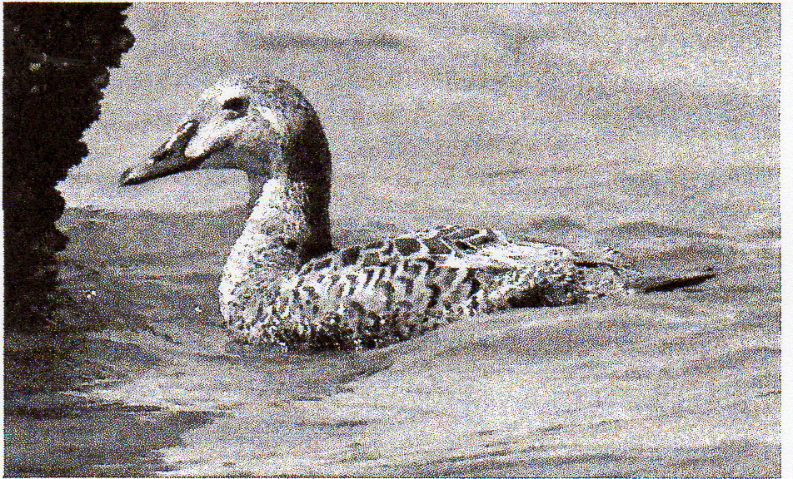
This first-year female King Eider found at Ocean Shores, Grays Harbor County 2 (here 3) July 2009 remained through the summer period. Only two of Washington's 19 records have occurred in summer. Photograph by Gregg Thompson.

Jun+ (BW, RM, TA). A Ring-necked Duck x scaup hybrid at L. Lenore, Grant 3 Jul ('ISM, DS) provided the first summer record of this cross for the Region and also the first e. of the Cascades. Single Greater Scaup, now nearly annual on the eastside during summer, were at the Burns S.T.P. 2 Jun (TJ) and the Coulee City S.T.P., Grant 3 Jul (SM, DS); nearly all records are from deeper water locations at which this species winters in numbers. Similarly, a single Greater at F.R.R. 16-20 Jun (DI) was an unexpected summer visitor in the Willamette Valley. Lesser Scaup produced three broods at Swantown L. 11 Jul (SM) and seven broods at Deer Lagoon 25 Jul (SM); they are generally scarce westside breeders. A King Eider, Washington's 19th and only the 2nd summer record, enlivened O.S. 2 Jul + (H. Vail); most records have occurred late Oct through early May, with only four occurring since 1989. Long-tailed Ducks are not annual in the Region during summer, thus one at O.S. 8-18 Jul was noteworthy (BS). The congregation of 150 Buffleheads on Agency L., Klamath 5 Jul (AS, ES) provides a record summer count for the eastside, where this species is a rare but local breeder. In recent years, Common Goldeneyes have proven to be rare but annual during Jun in e. Oregon; 5 were reported from four Harney/Malheur locations 1-6 Jun (TJ et al.). A Red-breasted Merganser near Adrian, Malheur 5 Jun (TJ) made just the 7th summer record e. of the Cascades.
The traditional gathering of non-breeding Western Grebes at Seaside, Clatsop held 600+ birds 9 Jul (MP). Only 4 Clark's Grebes were reported on the westside away from F.R.R., which has a breeding population of 15-20 pairs. The season's only Manx Shearwater was seen at Boiler Bay 14 Jun (W. Hoffman) Large numbers of American White Pelicans again wandered around the WV, with 35 as far n. as Ridgefield, Clark (R. Windemuth) and maxima of 100+ at F.R.R. 16 Jun (DI), 58 at Finley

646 NORTH AMERICAN BIRDS, Nesting 2009

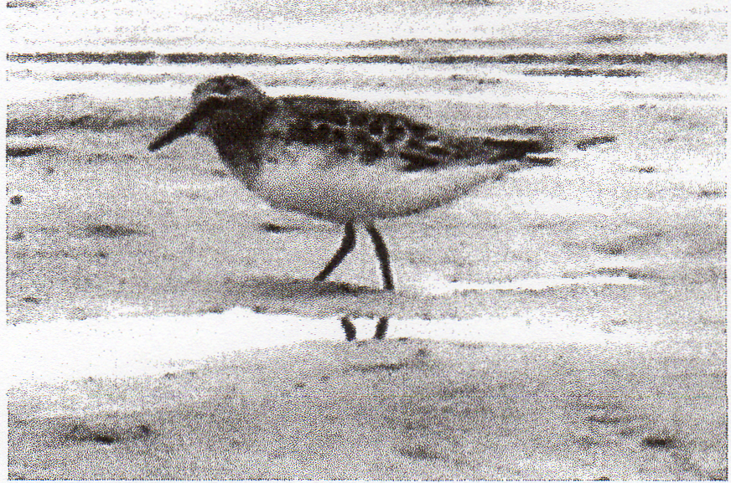
Seven of Oregon's nine previously accepted Red-necked Stints have been adults in alternate plumage or partial alternate plumage. Adult birds have appeared 20 June through 26 August. This adult was found on the open beach near the mouth of Termite Creek, Coos County 21 June 2009. Photograph by Hendrik Herlyn

N.W.R. 17 Jun (W. Wright) and 50+ at Baskett Slough 10 Jul (C. Shank). On the outer coast, where less than annual, flocks of 20 visited Tillamook 20 Jun (10, and 33 were e. of Astoria 23 Jun+ (MP et al.). Three near Suquamish, Kitsap 12 Jun (fide CW) and one at Padilla Bay, Skagit 14 Jun (MWi) were in the P.T., where still very rare. Probably related to this influx, 950 at Crab L., Grant 3 Jul (SM, DS) was likely e. Washington's largest congregation ever away from Potholes Res. For the first summer in six years, no Brown Pelicans were detected in the P.T. and incredibly none were reported n. of La Push, Clallam or in the Straits of Juan de Fuca. Conversely, the 22,000 tallied at East Sand I., Pacific 16 Jul (D. Jaques) was a Regional record. The Little Blue Heron, first detected in Nov 2008 at Siletz Bay, Lincoln, continued there through the period (D. Demarest et al). Two Cattle Egrets n. of Burns 2 Jun (TJ et al.) were the first summer season birds on the eastside since 2006.
A juv. Red-shouldered Hawk at Ridgefield 30 Jul and an ad. at Vancouver, Clark 21 Jul (T. Hicks) supplied Washington's 4th and 5th summer records (G. Neavoll). A Swainson's Hawk over Vancouver, Clark 28 Jun was only the 2nd ever during summer for the w. Washington (T. Hicks); the only other w. Washington summer record was from Jul 1968. Following up on one detection during summer 2008, up to 7 Yellow Rails were heard along the w. side of Summer L. during Jun (S. Carpenter et al.); this species was previously unknown from the Summer L. basin. The Common Moorhen that visited Borax L., Harney 4 Jul (J. Johnson) was the Region's 9th and the first since 2001; the eight antecedent records have all come from Oregon. A Sandhill Crane, extremely rare during summer in w. Washington, was near Carnation, King 29 Jul (T. Risdon).

SHOREBIRDS THROUGH WOODPECKERS
An American Golden-Plover, a species less than annual during summer, was at N.S.C.B. 4 Jul (TR). Once again, the Region hosted a Pacific Golden-Plover during Jun, with one at P.S.B. 7 Jun (SM). Another suspected Pacific was at N.S.C.B. 18 Jun (KC, DL); prior to 2001, such records were virtually unknown. The ad. Pacific that inhabited N.S.C.B. 48 Jul (TR) was more expected; 34 southbound ads. during Jul is typical in the Region. A pair of Semipalmated Plovers at Alvord L., Harney 5 Jun suggested possible nesting; this species is a rare nester in the Region. Two American Avocets reached the westside, one at Dunes Overlook, Douglas 1 Jun (DF, HH), the other at Baskett Slough N.W.R. 20 Jun (RG). The last apparent northbound Greater Yellowlegs was at P.S.B. 7 Jun (SM), while 2 at Smith I., Snohomish 13-20 Jun (SM, R. Shaw) were present between dates usually assigned to northbound and southbound migration. One Greater at P.S.B. (SM), 3 at F.R.R. (DI), and 4 at Baskett Slough N.W.R. (RG), all on 20 Jun, were likely the first southbound migrants. A Lesser Yellowlegs at P.S.B. 20 Jun was about on time for a first southbound migrant (SM). Washington had 17 Solitary Sandpipers, more than triple the Regional average, 11 Jul+, while Oregon had but two. There are no records of breeding Solitary Sandpiper in Washington, but one was in potential breeding habitat at Surprise L. 30 Jun; southbound birds rarely reach the Region before mid-Jul. A juv. Willet at Bandon 22 Jul (TR) was a bit surprising, as they rarely return to the s. Oregon coast before late fall. It would seem that The Region's remnant breeding population of Upland Sandpipers is now likely extirpated—none were detected in Oregon's Bear Valley for the fourth straight summer. A Whimbrel at Alvord L., Harney 6 Jun (JGi, OS) adds to about 10 prior e. Oregon summer records, while another at Baskett Slough N.W.R. 12 Jul (RG) provided a rare summer record for the WV Marbled Godwits were noted at Dungeness, Clallam 2-25 Jul; 30 there on 10 Jul (GGe) is among the highest counts ever for the PT., where they are generally rare. Forty-eight Marbleds bejeweled the W.W.R.D. 12 Jul (M&MLD), nearly triple the e. Washington record for any season. A Red Knot, very rare during summer in the PT., was at Dungeness 25 Jul (RM, T. Mansfield).
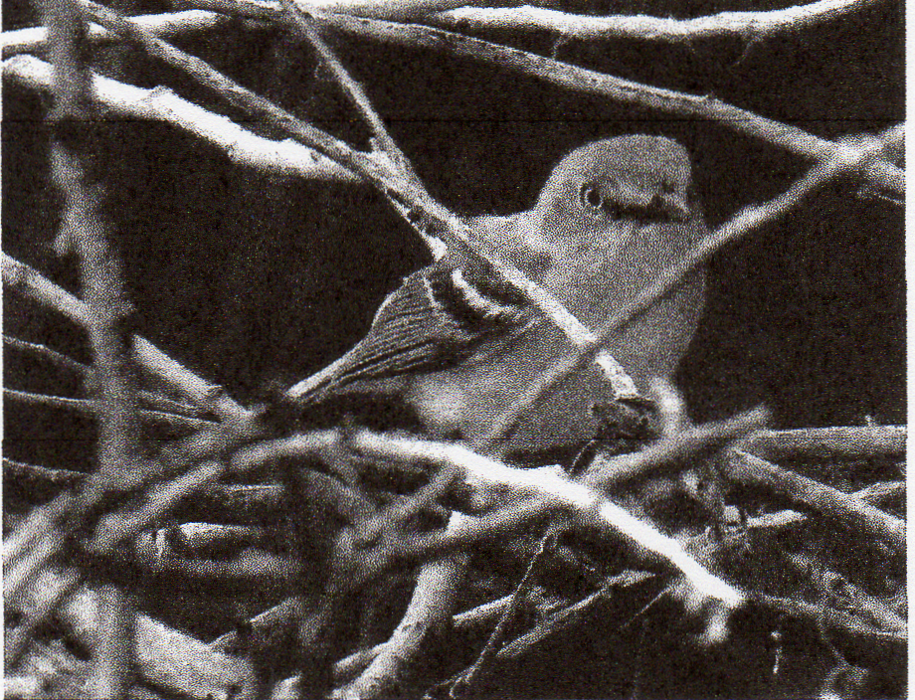
Oregon's first White-eyed Vireo, found at Fields, Harney County on 9 June 2009, was in a woodlot that has produced many state firsts over the years. Photograph by Graham Floyd

An above-average 93 Semipalmated Sandpipers 27 Jun-29 Jul were tallied in w. Washington, including a Washington record 34 ads. at P.S.B. 5 Jul (SM, RM); 16 in e. Washington 3 Jul+ was slightly below average. Eight Semipalmateds in Oregon 1-22 Jul was an above-average summer showing. Each state hosted an ad. Red-necked Stint. Oregon's 10th was at the mouth of Tenmile Cr., Coos 19 Jun (DF, HH), and Washington's 3rd brightened O.S. 24 Jul (vt. BW, GGe, J. Acker, DWg); all but three of the Region's records have involved alternate-plumaged ads. detected 20 Jun-2 Aug. Five westside Baird's Sandpipers included one that was about two weeks early at P.S.B. 25 Jun (RM, TA, TB); ads. typically arrive in small numbers starting in early Jul, with juvs. arriving during late Jul. All but one of 30 eastside Baird's 12 Jul+ were in Washington, where the tally was quintuple the seasonal average. A Pectoral Sandpiper at P.S.B. 7 Jun was two or three weeks late and furnished the 2nd latest record ever of a northbound bird (SM). Six more Pectorals visited Washington during Jul, including 4 on the eastside 12-17 Jul. Dunlins were once again found in summer on the westside; one northbound bird at Sutherlin, Douglas 2 Jun OH) and 2 more at Crockett L., Island 6 Jun (BW) were about three weeks late, while one at P.S.B. 20 Jun (SM), 2 at Ridgefield 2 Jul (BF), and one at P.S.B. 11 Jul (SM, RM) were likely exceptionally early

647 Volume 63 (2009) Number 4, Nesting Season

southbound birds. Though individuals often summer on the outer coast, each summer a few are found among other southbound shorebirds in late Jun and Jul, about two months ahead of the "normal" fall arrivals. Single Short-billed Dowitchers at N.S.C.B. 5 Jun (TR) and P.S.B. 7-13 Jun (SM, DFi) and a Long-billed Dowitcher at Nisqually 10 Jun (BS) defied categorization as to their migration status. A tally of 380 Long-billeds at F.R.R. 10 Jul (JS) reflected the first influx of southbound adults. An apparent southbound migrant Wilson's Snipe was at P.S.B. 20 Jun (SM); migration dates for this species in the Region are poorly understood. Wilson's Phalaropes were once again at P.S.B., recently considered their only w. Washington breeding site, and included an ad. high count of 48 on 7 Jun; at least 10 males guarded nests during Jun (SM). However, breeding was also confirmed at Midway Beach, Pacific, with an ad. male performing a "distraction display" flight 16 Jul (BW, TA, RM) followed by 2 downy juvs. noted 30 Jul (ph. G. Thompson). Baskett Slough N.W.R. can be added to the list of W.V. sites, with burgeoning nesting populations of Wilson's; 40 juvs. were counted there 14 Jul (RG). Most surprising was an ad. female Wilson's Phalarope observed 35 km w. of Cape Alava, Clallam 17 Jul (CW, BW, RM, P. Hodum); this species had not been previously recorded offshore in Washington. Single Red-necked Phalaropes at Burns 2 Jun (TJ et al.) and Beverly Beach, Lincoln 3 Jun (D. Bailey) were the latest northbound birds. The migratory status of lone Red-neckeds at Gleneden Beach, Lincoln 18 Jun (DB) and P.S.B. 20 Jun (SM) was less clear, as they would be exceptionally early southbound migrants.
A Parasitic Jaeger was at Partridge Pt., Island 27 Jun (SM), and a Pomarine Jaeger was there 11 Jul (SM, RM); jaegers of any species are rare in the P.T. prior to Aug. Up to 4 Franklin's Gulls at Sprague, Lincoln were the only ones reported this summer in e. Washington, about half the recent norm (m.ob.). An exceptional count of 7500 Heermann's Gulls came from O.S. 24 Jul (BW). Mew Gulls (mostly imms.) are rare but annual on the westside during summer, and 2 were at Useless Bay, Island 7 Jun (SM). A Glaucous Gull at Westport, Grays Harbor 25 Jul+ furnished only the 2nd summer record for Washington (BS, S. Mills, B. Labar). The season's only Elegant Terns were 13 at Gold Beach, Curry 25 Jul (DMu); despite weak El Nino conditions, no major invasion materialized during the early fall season.
Arctic Terns again nested at Dungeness Spit, Clallam, where they were first noted in 2004, with 2 ads. and a chick observed there 10 Jul (GGe). Noteworthy in the P.T. away from Dungeness Spit, one visited Crockett L., Island 27 Jun (SM). A Forster's Tern visited Everett 13 Jun (SM, R. Shaw); there are only about eight previous summer records for this species in w. Washington. A presumed northbound Black Tern, rare in the R.T., visited Nisqually 3 Jun (BS). A summer-record 300 Marbled Murrelets congregated near Pt. Wilson, Jefferson 21 Jun (GGe). Eight Ancient Murrelets were near Ediz Hook, Clallam 1 Jun (D. Wheelan), and one was near Observation Pt., Clallam 31 Jul (BW); this species is not annual during summer in the Straits of Juan de Fuca. Also in the Straits, and more surprising, were 2 ads. with 2 chicks near Protection I., Jefferson 14-19 Jun (ph. T. Amico). A Tufted Puffin, very rare in the e. Puget Trough, was near Edmonds, Snohomish 11 Jul (T. Haas).
Band-tailed Pigeons are rare in e. Washington away from w Klickitat, so singles at Toppenish, Yakima 3 Jun (fide Denny Granstrand) and at Farmer, Douglas 8 Jul (MWi) were noteworthy. A White-winged Dove, first detected at Frenchglen 30 May, remained through 3 Jun (AC), and another was at Florence, Lane 7 Jun (WH); most records of this species, now annual in the Region, come during fall. A calling Yellow-billed Cuckoo was in suitable breeding habitat at the Sandy R. mouth, Multnomah 2223 Jul QW, JGa); the bulk of the Region's record have come from se. Oregon oases during late May and early Jun. A Northern Hawk Owl near Tatoosh Butte, Okanogan 17 Jul (ph. V. Glick) continues the recent trend of back-country sightings during breeding season. Although no young were located, it is likely that this bird bred in the area. A congregation of 98 Common Nighthawks (all ads.) about 19 km n. of Moses L., Grant 3 Jul (ph. SM, DS) was likely a seasonal record. It is unknown why so many assembled at one site so early in the season. A Black-chinned Hummingbird, extremely rare for w. Washington, was at Naches Pass, King 19 Jul (EH). Four Calliope Hummingbirds were located on the westside, 21 Jun-12 Jul. Though small numbers of Calliopes occur w. of the Cascades in spring, they are still rather rare there during summer, and breeding has yet to be documented. Yet another Acorn Woodpecker wandered e. of the Cascades, where formerly extremely rare; this season's bird inhabited Malheur N.W.R. 1-14 Jun (C. Chutter et al.). Rare at any season w. of the Cascades, a Red-naped Sapsucker was at the County Line Ponds, Whatcom (ph. RM, TA, T. Brooks). Almost certainly the result of increased observer scrutiny, an exceptional 3 Red-naped Sapsucker x Red-breasted Sapsucker hybrids were detected in w. Washington lowlands 10 Jun-19 Jul.

PASSERINES
The ongoing range of Least Flycatchers into the Region continued, with no fewer than 11 holding breeding territories in e. Washington 3-21 Jun. In w. Washington, an unprecedented 4 territorial males were detected, including 3 in King 10 Jun-19 Jul and one near Oakville, Grays Harbor 21-25 Jun (T. Schooley). In Oregon, where Least Flycatchers have summered and bred sporadically, singles were at Fort Klamath, Klamath 26 Jun (A. McCallum) and n. of Sisters 3 Jul+ (S. Shunk). Washington's 13th Black Phoebe was near Willapa Bay, Pacific 24 Jul (ph. JGi); this species has been expanding its range northward, and most of the records are from sw. Washington. An Ash-throated Flycatcher at Northrup Canyon, Grant 3 Jul (SM, DS) was 350+ km ne. of the nearest known breeding location. A northbound Ash-throated strayed to Newport 8 Jun (11.); this species is near annual on Oregon's outer coast in early Jun. Aside from expected pairs at the Sandy R. mouth, the only w. Oregon Eastern Kingbird was at Cape Blanco 4 Jul (K. Andersson).
Oregon's first White-eyed Vireo enlivened Fields 9 Jun (AC, ph. GF). This species has rarely occurred n. of cen. California along the West Coast; one at Vashon I., King 11 Jul 1981 is the only prior Regional record. A singing Red-eyed Vireo along Balch Cr. in nw. Portland 16 Jun (AH, CH) and another at Freyer Park, near Molalla, Clackamas 19 Jun (TJ) were at locations where they have not been detected previously; given the abundance of suitable breeding habitat, there are likely many such pairs in the Willamette Valley. Clark's Nutcrackers inexplicably showed up in several lowland locations where they are rare at any season; these included 2 at Richland, Benton (117 m elevation) 2 Jun (fide NL), 2 at Trout L., Klickitat (580 m) 27 Jun (S)), and singles at Saddle Mt., Adams (823 m) 30 Jun (SDs) and the mouth of Northrup Canyon, Grant (550 m) 3 Jul (SM, DS); the latter provided just the 2nd record for Grant. Western Scrub Jays maintained their foothold in e. Washington, evidenced by singles at Ward Gap Rd., Benton 1 Jun (MH) and Yakima, Yakima 28 Jul (SDs). A wayward Black-billed Magpie near Tacoma 31 Jul (J. Meyer) made w. Washington's 2nd summer record and only the 3rd at any season since 1988; prior to the 1980s, this species was considered a rare but somewhat regular winter visitor to the westside. Over the past decade, Red-breasted Nuthatches have started summering in the Columbia Basin, where formerly absent during the breeding season. They now summer annually at Othello (RH), and this summer, they were also noted from

648 NORTH AMERICAN BIRDS, Nesting 2009

Moses L. (DS), Wanapum Dam S.P., Kittitas (SM), and Sentinel Bluffs, Grant (SM). They seem to be expanding their breeding range into the Columbia Basin, mostly at isolated parks and towns with mature trees, especially conifers.
A Barn Swallow x Cliff Swallow hybrid enlivened P.S.B. 13 Jun (†SM, R. Shaw); this cross has only been recorded once previously in the Region. A w. Washington record 300 Bank Swallows inhabited the colony near Concrete, Whatcom 9 Jul, providing further evidence of this species' continuing establishment on the westside (TA). A single Bank at New River, Coos 10 Jul (KC, DL) was far removed from known breeding colonies. Though Rock Wrens are occasionally found in the nearby Coast Range, one along Beaver Creek Rd. near Seal Rock, Lincoln 5 Jul (C. Philo) was out of place on the coastal plain. A Blue-gray Gnatcatcher at Gray Butte, Jefferson 17 Jun (K. Owen) was at a site where they were suspected breeding in 2007; the only other county record came from nearby Haystack Res. in Jun 1992. A Veery was at their only westside breeding location near County Line Ponds, Whatcom 18-25 Jun (GB). Another Olive-backed Swainson's Thrush (subspecies group swainsoni) was at Rainy Pass, Skagit 23 Jul (TA); the breeding range of Olive-backed in Washington was previously thought to be limited to ne. highlands plus the Blue Mts. in Oregon, with all breeders on both slopes of the Cascade Mts. considered to be Russet-backed Swainson's Thrushes (subspecies group ustulatus). Recent study has revealed that swainsoni breed extensively on the e. slope of the Washington Cascades and w. of the Cascades in British Columbia, so one would assume that small numbers breed w. of the Cascades in Washington as well. A tally of 52 Hermit Thrushes along 4 km of trail between Union Gap and L. Janus, Snohomish 18 Jul set a Washington summer high count and displayed the amazing breeding density these birds can reach in Washington's Cascades (SM, DFi). A Gray Catbird, extremely rare in w. Washington, was near Snoqualmie, King 14-17 Jun (†B); the only previous King record was in 1931! In Oregon, 3 catbirds were away from traditional sites; a migrant lingered at Malheur 1-11 Jun (AC et al.), and another likely migrant visited Pine Grove, Wasco 2 Jun (W. Gross, J. Fitchen, A. Frank). Another was along the Little Deschutes R. near Gilchrist, Klamath 18 Jun (KS); Gray Catbirds have now appeared in nw. Klamath and sw. Deschutes for several consecutive breeding seasons, which suggests the establishment of a small and localized nesting population in the upper Deschutes R. watershed. Five Northern Mockingbirds in Oregon was about the seasonal norm; all 3 westside birds were in Lincoln 1-11 Jun, and both eastside birds were in Klamath 2-3 Jun. The only mockingbirds in Washington, which averages about 2 per summer, were on the eastside at Sacajawea S.P., Benton 7 Jun (L. Ness) and n. of Ephrata, Grant 14 Jun (R. & C. Youel). A very tardy American Pipit was near Silverdale, Kitsap 1 Jun (BW, M. Breece); there are very few lowland records for this species in w. Washington during summer. A Phainopepla, only Washington's 2nd if accepted by the Washington B.R.C., was at Mill Creek, Snohomish 31 Jul and 5 Aug (†N. Johnson); Washington's previous record came from Seattle in Sep 1994.
A Townsend's Warbler x Hermit Warbler near L. Janus 18 Jul provided Snohomish's first record of this hybrid (SM, DFi); Snohomish remains without a record of a pure Hermit Warbler. A Hermit Warbler at Mt. Vernon, Grant 17 Jun (T. Winters) was nearly 200 km e. of the species' normal breeding range in the Cascades. Oregon's 7th Yellow-throated Warbler sang persistently as it moved quickly through Netarts, Tillamook 2 Jun (†D. Vander Pluym, †L. Harter). The season's Black-and-white Warbler brightened Bullard's Beach S.P. 24 Jun (†JW). American Redstarts were again noted at their isolated well-established colony at County Line Ponds, Whatcom, with a maximum of 8 ads. there 25 Jun (RM, TA. TB). Two ad. males and one ad. female were found 12 Jun near Carnation, King (C. Anderson), and later observations from there through 26 Jul established King's first breeding record (EH). An Ovenbird at Cold Springs Campground w. of Sisters, Deschutes 26 Jul (H. Horvath) may have summered locally; there are few records outside of the traditional late May—early Jun window in which most of the Region's records have fallen. A singing male Hooded Warbler in a sw. Portland yard 7 Jul (†T. Love) was most unexpected; the majority of Oregon's 11 antecedent records have come from vagrant traps during spring and fall migration. Breeding Yellow-breasted Chats have increased in w. Washington over the past five years, but this summer, only 3 territorial males were noted 3-22 Jun.
A subad. male Summer Tanager at Malheur headquarters 2 Jun (GF, TR) was followed up by a female 56 km to the s. at Page Springs Campground 6 Jun (J. Spencer).; more than half of Oregon's 17 prior records have come May—Jun. Clay-colored Sparrows reports continue to increase in n.-cen. and ne. Washington, with 10 birds on breeding territory noted from 6 Jun-5 Jul, nearly double the ten-year average. The lone extralimital Lark Sparrow of the season was at the Siltcoos R. mouth, Lane 10 Jun (DF); this species is a rare but annual spring stray on the s. Oregon coast, but much rarer this far north. A single Black-throated Sparrow was at Steptoe Butte, Whitman 14 Jun (Terry Gray), and another male was near Vantage 16-27 Jun (GG) (MH); the Vantage site is Washington's most reliable site for this species, whereas Black-throateds are a recent addition to the avifauna of Steptoe Butte. Similarly, a Black-throated at Painted Hills S.P., Wheeler 20 Jun (JGe) marks at least the 3rd consecutive year that they have appeared at this locale. Western Washington's 6th Grasshopper Sparrow, and 2nd for summer, was at Ridgefield 9 Jun (BF). A late northbound Golden-crowned Sparrow was in Seattle 4 Jun (fide CW), while another near Loraine, Lane 17 Jun (DI) may have been summering; most Golden-crowneds depart the Region by mid-May. A Snow Bunting at Dunes Overlook, Douglas 6 Jun (R. Namitz) appears to be a summer season first for the Region; on the westside, this species is usually gone by mid-Apr, and there are few May records.
Nine Rose-breasted Grosbeaks 1-23 Jun was a typical showing. A Lazuli Bunting at Cascade Head, Tillamook 7 Jul (PP) may have been summering; a few migrants are detected at this site most springs, but they are otherwise rare on Oregon's n. coast. Indigo Buntings again showed exceptionally, matching the 6 found during summer 2008; historically, the Region has averaged one or 2 per summer. Half of these birds remained or were initially detected during Jul, suggesting that they summered; Indigo Bunting x Lazuli Bunting hybrids, reported each of the past two summers near Eugene, went undetected this season. The Umpqua Valley's lone Tricolored Blackbird outpost persists at Sutherlin, where 8 birds were present 2 Jun (JH). After several years of suspected breeding in the general vicinity, Yellow-headed Blackbirds finally bred at P.S.B. (SM, TA); there are only a few known active nesting locations in w. Washington, none of which are in Snohomish. The Great-tailed Grackle at Liberty L., Spokane continued from the spring period and was last reported 8 Jun (Ron Dexter); all 5 in Oregon were w. of the Cascades. Washington's 6th Baltimore Oriole was at Richland, Benton 21 Jul (†Patricia Rutherford); this species remains surprisingly rare in that state, considering they appear annually in Oregon. Cassin's Finches, rare on the w. slope of the Cascades, included one near Mt. Hardy, Skagit 12 Jul (GB, H. Armstrong), 6 at Naches Pass, King 19 Jul (EH), and 3 at Mt. Hardy 29 Jul (TA). The lone White-winged Crossbills of the season were at Waldo L., Lane 20

649 Volume 63 (2009) Number 4, Nesting Season

& 22 Jul (R. Maertz). Numbers of Evening Grosbeaks in the W.V. and in Oregon's Coast Range were far above the norm throughout the season (m.ob.).

Observers (subregional and eBird compilers in boldface): Tom Aversa (Washington), Gary Bletsch, Justin Bosler, Tayler Brooks, Kathy Castelein, Alan Contreras, Craig Corder (Spokane), Scott Downes, Daniel Farrar, Debbie Fischer, Bob Flores, Graham Floyd, John Gatchet, Chuck Gates (Crook), Joel Geier, George Gerdts, Roy Gerig, Jeff Gilligan, Greg Gillson (Washington, The Bird Guide Pelagics), Denny Granstrand (Yakima), Jim Hein, Hendrik Herlyn, Randy Hill, Adrian Hinkle, Christopher Hinkle, Michael, Hobbs, Wayne Hoffman, Eugene Hunn, Tim Janzen, Stuart Johnston (Hood River, Klickitat), Bill LaFramboise (Lower Columbia Basin), Nancy LaFramboise (Lower Columbia Basin), Janet Lamberson, Dave Lauten, Ryan Merrill, Craig & Marilyn Miller (Deschutes, Jefferson), Steve Mlodinow, Don Munson, Harry Nehls (Oregon), Mike Patterson (Clatsop), Tim Rodenkirk (Coos, Curry), Owen Schmidt, Bill Shelmerdine, Doug Schonewald, Kevin Spencer (Klamath), W. Douglas Robinson (Benton, Polk), Andy Stepniewski, Ellen Stepniewski, John Sullivan, Julie Van Moorhen, Dan Waggoner, Michael Willison, Jay Withgott, Charlie Wright (eBird).

The End

